# 3. Software Requirement Specifications

## 3.1. User Requirement Specification

The users of system are devided into five specific groups:

1. **Guest**: Guest is a person who does not have accessed to the system, but can use some functions in the system. In order to use more functions, guest must registry and login to the website. The typical functions which can be used by guest are **Search Job** and **View Job**. Guest can choose register for a Job Seeker account or Recruiter account.
2. **Job Seeker**: Jobseeker Seekers are guests who have successfully logged into system with their accounts. They can use additional functions, such as **Manage Own CV** and **Apply Job**.
3. **Recruiter**: Recruiters are the people who represent for their companies to post job and recruit staff. They can use some special function such as: **Buy Job Package**, **Manage Job** and **Manage Candidate**.
4. **Staff:** Staffs are people who work for the website and take responsible for **Manage Topic** and **Manage Request** form Receuiter.
5. **Manager:** Manager is a person who manages the activities of website and takes care of the running services. He can **View Statistic Report**, **Manage Job Package** and **Process Advertise Request** from receuiter.
6. **Administrator:** Admin is the person who take care of the website and can use the following functions: **Manage Advertise** and **Manage Account**.

|  |  |  |  |  |  |  |
| --- | --- | --- | --- | --- | --- | --- |
| Function | Guest | JobSeeker | Recruiter | Staff | Manager | Administrator |
| Register | ✓ | - | - | - | - | - |
| Login | - | ✓ | ✓ | ✓ | ✓ | ✓ |
| Logout | - | ✓ | ✓ | ✓ | ✓ | ✓ |
| Get Job Alert | ✓ | ✓ | - | - | - | - |
| Find Job | ✓ | ✓ | - | - | - | - |
| View Job Detail | ✓ | ✓ | - | - | - | - |
| View Company Detail | ✓ | ✓ | - | - | - | - |
| Save Job | - | ✓ | - | - | - | - |
| Apply Job | - | ✓ | - | - | - | - |
| View/Delete Applied Job | - | ✓ | - | - | - | - |
| Manage Own CV | - | ✓ | - | - | - | - |
| Manage Own Skill | - | ✓ | - | - | - | - |
| Manage Company | - | - | ✓ | - | - | - |
| View Job Seeker’s CV | - | - | ✓ | - | - | - |
| Buy Job Package | - | - | ✓ | - | - | - |
| Manage Job | - | - | ✓ | - | - | - |
| Buy Advertise | - | - | ✓ | - | - | - |
| View Transaction | - | - | ✓ | - | - | - |
| Manage Applicant | - | - | ✓ | - | - | - |
| Process Job Package Request | - | - | - | ✓ | - | - |
| Manage Common List | - | - | - | ✓ | - | - |
| View Statistic Report | - | - | - | - | ✓ | - |
| Manage Advertise | - | - | - | - | - | ✓ |
| Manage Advertise Cost | - | - | - | - | ✓ | - |
| Process Advertise Request | - | - | - | - | ✓ | - |
| Manage Job Package | - | - | - | - | ✓ | - |
| Manage Account | - | - | - | - | - | ✓ |
| Send Report | - | ✓ | ✓ | - | - | - |
| Manage Report | - | - | - | ✓ | ✓ | ✓ |
| Manage Own Message | - | ✓ | ✓ | ✓ | ✓ | ✓ |
| Write Topic | - | ✓ | ✓ | ✓ | ✓ | ✓ |
| Manage Topic | - | - | - | ✓ | - | - |

**Table 3-1**: Functional Requirement

## 3.2. System Requirement Specification

### 3.2.1. External Interface Requirements

#### 3.2.1.1. User Interfaces

* General requirement for graphics user interface is the GUI should be simple, clear, intuitive, and reminiscent.
* The interface design is an iterative process includes: design, sketching, prototyping, user assessment.

#### 3.2.1.2. Hardware Interfaces

N/A

#### 3.2.1.3. Software Interfaces

Job Searching System can run with multiple browsers such as:

* Firefox (33.1.0.5423)
* Chromes (version 39.0.2171.71)
* Cốc Cốc (version 35.0.1916.157)

And must support JavaScript and HTML5

#### 3.2.1.4. CommunicationsProtocol

Using HTML/HTTPS protocol

### 3.2.2. Functional Requirements

This section will describe the system being built through a list of Use cases. First, we will have an over-view of the whole system and what it will do through a use case diagram. There’re 6 main actors: Guest, Jobseeker, Recruiter, Staff, Manager and Administrator.

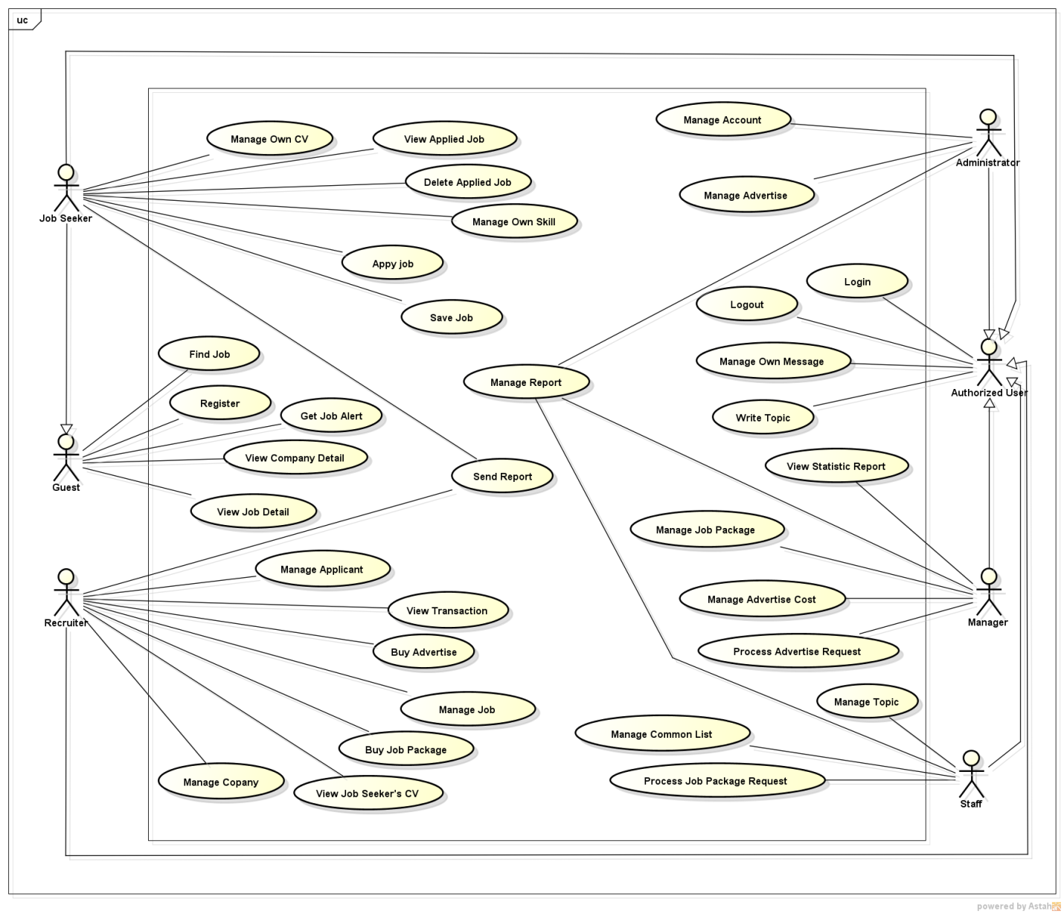

**Figure 3-1**: Use case overview

#### 3.2.2.1. <Guest> Overview Use Case

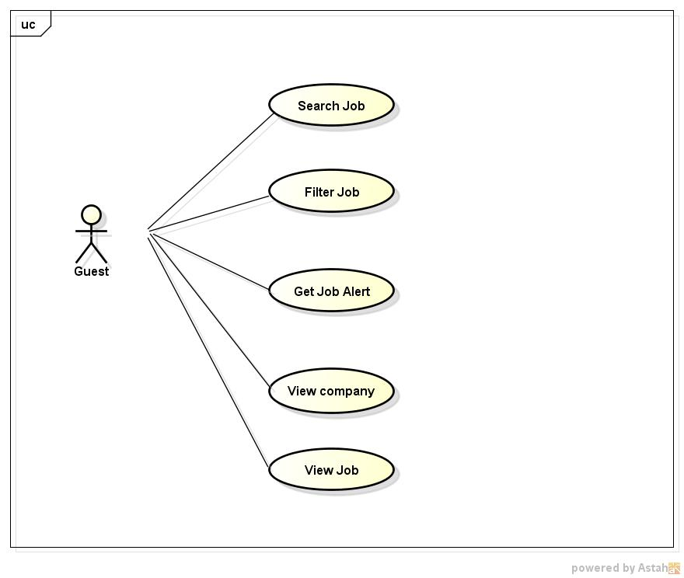

Figure 3-2: <Guest> Overview Use Case

##### 3.2.2.1.1. <Guest> Search Jobs

###### 3.2.2.1.2.1. Use case Diagram

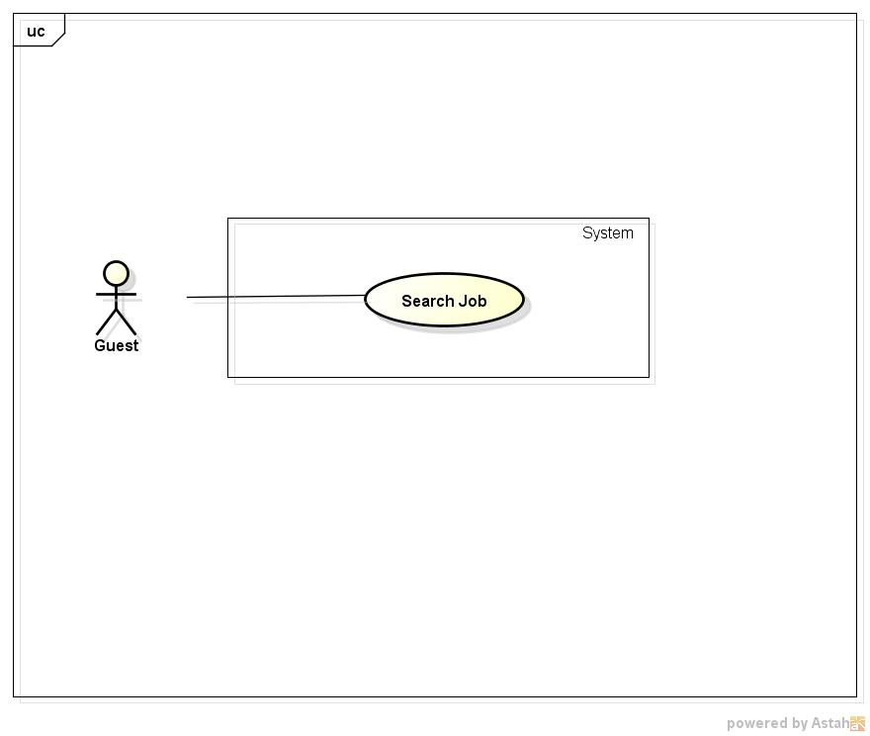

**Figure 2: <Guest> Search Jobs Use Case Diagram**

###### 3.2.2.1.2.1. Use case Specification

|  |  |  |  |
| --- | --- | --- | --- |
| **USE CASE –001** | | | |
| **Use Case No.** | 001 | **Use Case Version** | 1.0 |
| **Use Case Name** | Search Jobs | | |
| **Author** | Nguyen Ngoc Thien | | |
| **Date** | 18/05/2015 | **Priority** | High |
| **Actor:**   * Guest * Jobseeker * Recruiter * Manager * Administrator   **Summary:**   * User can make a quick search to find out information about jobs they concern by its name right after entering to website   **Goal:**   * Search for jobs by its name directly from home page   **Triggers:**   * Job Searching System homepage screen is displayed   **Preconditions:**   * Job Searching System homepage screen is displayed, the job name is entered and Search button is clicked.   **Post Conditions:**   * Job Searching System display a list of job   **Main Success Scenario:**   |  |  |  | | --- | --- | --- | | Step | Actor Action | System Response | | 1 | Type job’s name into search box on Job Searching System homepage | Auto-complete feature will check and gives suggested list bases on characters that user input | | 2 | Click “Tìm kiếm” button | Display a list of job or show message “Không thể tìm thấy công việc nào” |   **Alternative Scenario:**  N/A  **Exceptions:**  N/A  **Relationships:**  N/A  **Business Rules:**  When user enter job’s name system will search all job’s name in the database that is checked by Manager or Administrator | | | |

##### 3.2.2.1.2. <Guest> Filter Job

###### 3.2.2.1.2.2. Use case Diagram

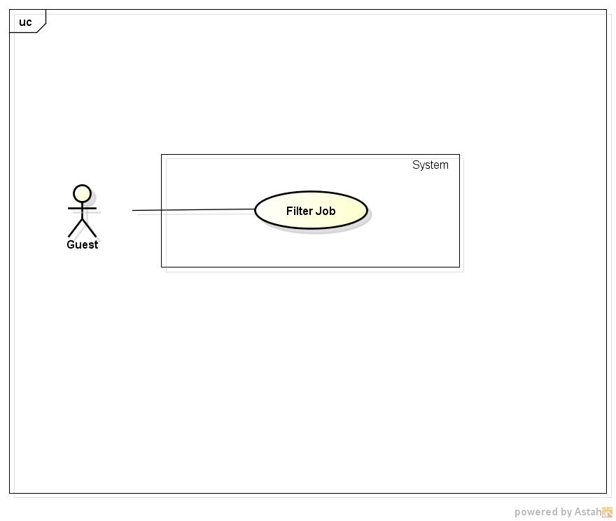

**Figure 3: <Guest>Filter JobUse Case Diagram**

###### 3.2.2.1.3.2. Use case Specification

|  |  |  |  |
| --- | --- | --- | --- |
| **USE CASE –002** | | | |
| **Use Case No.** | 002 | **Use Case Version** | 1.0 |
| **Use Case Name** | Filter Job | | |
| **Author** | Nguyen Ngoc Thien | | |
| **Date** | 18/05/2015 | **Priority** | High |
| **Actor:**   * Guest * Jobseeker * Recruiter * Manager * Administrator   **Summary:**   * This use case allow user see jobs that suitable with their criteria by choose condition like categories, job level or location   **Goal:**   * Filter jobs by categories, job level, location   **Triggers:**   * User select criteria to filter jobs   **Preconditions:**   * Job Searching System homepage screen is displayed   **Post Conditions:**   * Jobs that are suitable with filter criteria will be displayed   **Main Success Scenario:**   |  |  |  | | --- | --- | --- | | Step | Actor Action | System Response | | 1 | From Job Searching System home page , user choose criteria to filter  Criteria contains: “Nghành nghề”, “Cấp bậc”, “Mức lương”,”Địa Điểm” | * Searching in database all of jobs that satisfy filter criteria * Display a list of jobs that suitable with those criteria or show message “Không có công việc nào thỏa tiêu chí của bạn” |   **Alternative Scenario:**  N/A  **Exceptions:**  N/A  **Relationships:**  N/A  **Business Rules:**   * System only filters with jobs in database that is censored by manager | | | |

##### 3.2.2.1.3. <Guest>Get Job Alerts

###### 3.2.2.1.3.1. Use case Diagram

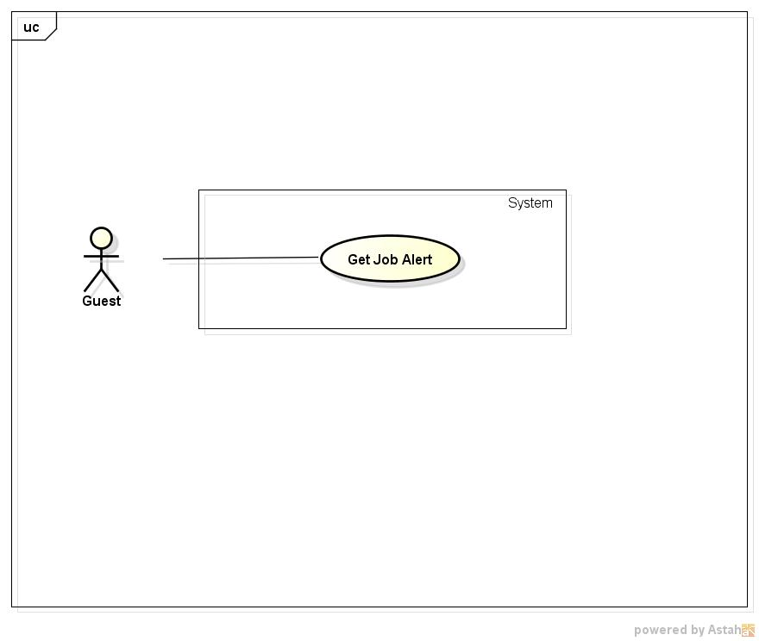

**Figure 4: <Guest>Get Job Alerts Use Case Diagram**

###### 3.2.2.1.3.2. Use case Specification

|  |  |  |  |
| --- | --- | --- | --- |
| **USE CASE –003** | | | |
| **Use Case No.** | 003 | **Use Case Version** | 1.0 |
| **Use Case Name** | Get Job Alerts | | |
| **Author** | Nguyen Ngoc Thien | | |
| **Date** | 18/05/2015 | **Priority** | High |
| **Actor:**   * Job Seeker * Guest   **Summary:**   * This use case allow user to get a job alert via email   **Goal:**   * Auto-mailed to user who have registered receiving job alert via email whenever have a new job   **Triggers:**   * Click on “Gửi việc cho tôi” button on homepage * Choose job category, job level and fill email , then click button “Đăng ký nhận việc”   **Preconditions:**   * Job Searching System homepage is displayed successfully   **Post Conditions:**   * User’s email is registered for receiving job alert via email.   **Main Success Scenario:**   |  |  |  | | --- | --- | --- | | Step | Actor Action | System Response | | 1 | Click “Gửi việc cho tôi” button on Job Searching System homepage | Redirect to “Thông báo việc làm” page contains :   * “Nghành nghề” combo box contains fields of job. Ex: Accounting, Advertising, etc. * “Vị trí” combo box contains positions of job. Ex: Staff, Manager, Team leader, etc. * “Email của bạn” textbox * “Đăng ký nhận việc” button | | 2 | Click “Đăng ký nhận việc” button | Register email for receiving job alert to database |   **Alternative Scenario:**  N/A  **Exceptions:**  N/A  **Relationships:**  N/A  **Business Rules:**   * When job seeker using this function, email will be auto filled to “Your email” text field | | | |

##### 3.2.2.1.4. <Guest> View company

###### 3.2.2.1.4.1. Use case Diagram

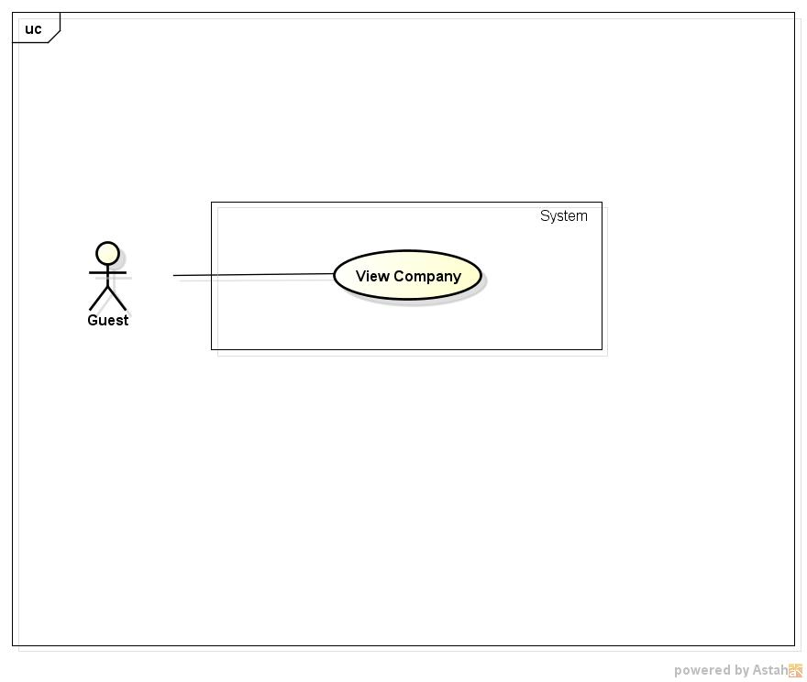

**Figure 5: <Guest>View Company Use Case Diagram**

###### 3.2.2.1.4.2. Use case Specification

|  |  |  |  |
| --- | --- | --- | --- |
| **USE CASE –004** | | | |
| **Use Case No.** | 004 | **Use Case Version** | 1.0 |
| **Use Case Name** | View Company | | |
| **Author** | Nguyen Ngoc Thien | | |
| **Date** | 18/05/2015 | **Priority** | High |
| **Actor:**   * Job Seeker * Guest * Administrator * Manager * Recruiter   **Summary:**   * This use case allow user to view profile of a company   **Goal:**   * Allow user view detail information of a company   **Triggers:**   * Click on a company name link   **Preconditions:**   * Have at least a company on Job Searching System   **Post Conditions:**   * Company profile page is displayed successfully   **Main Success Scenario:**   |  |  |  | | --- | --- | --- | | Step | Actor Action | System Response | | 1 | Select a company name link on Job Searching System | Redirect to “Thông tin công ty” page |   **Alternative Scenario:**  **N/A**  **Exceptions:**  **N/A**  **Relationships:**  **N/A**  **Business Rules:**  **N/A** | | | |

##### 3.2.2.1.5. <Guest>View Job

###### 3.2.2.1.5.1. Use case Diagram

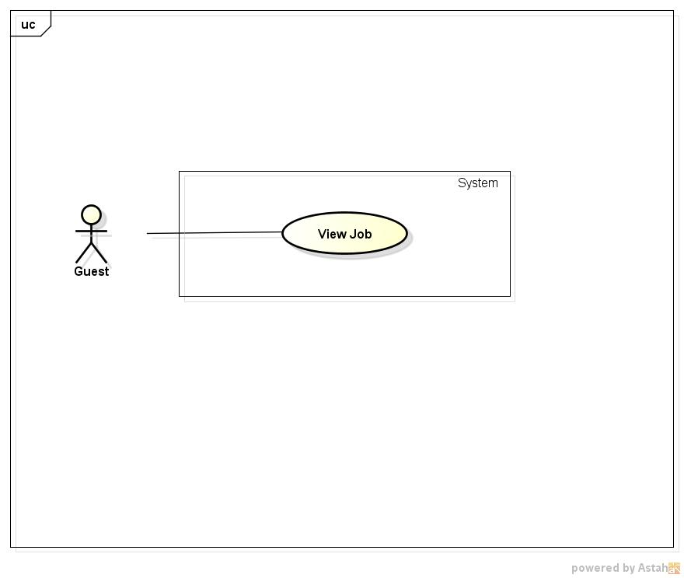

**Figure 6: <Guest>View Job Use Case Diagram**

###### 3.2.2.1.5.2. Use case Specification

|  |  |  |  |
| --- | --- | --- | --- |
| **USE CASE –005** | | | |
| **Use Case No.** | 005 | **Use Case Version** | 1.0 |
| **Use Case Name** | View Job | | |
| **Author** | Nguyen Ngoc Thien | | |
| **Date** | 18/05/2015 | **Priority** | High |
| **Actor:**   * Guest * Jobseeker * Recruiter * Manager * Administrator   **Summary:**   * When user click a job post link, redirect to job’s information page   **Goal:**   * Display detailed information of clicked job   **Triggers:**   * Click job post link on homepage or search result page   **Preconditions:**   * Job Searching System homepage screen is displayed and has at least one job or on the job searching result page has at least one job   **Post Conditions:**   * Job Information page is displayed   **Main Success Scenario:**   |  |  |  | | --- | --- | --- | | Step | Actor Action | System Response | | 1 | Click on job post link in home page or on job searching result page | Redirect to “Thông tin công việc” page |   **Alternative Scenario:**  N/A  **Exceptions:**   |  |  |  | | --- | --- | --- | | No | Actor Action | System Response | | 1 | Click on job post link in home page or on job searching result page which was deleted in database | Show error message “ Công việc này không tồn tại” |   **Relationships:**  N/A  **Business Rules:**  N/A | | | |

#### 3.2.2.2. <Job Seekers> Overview Use Case

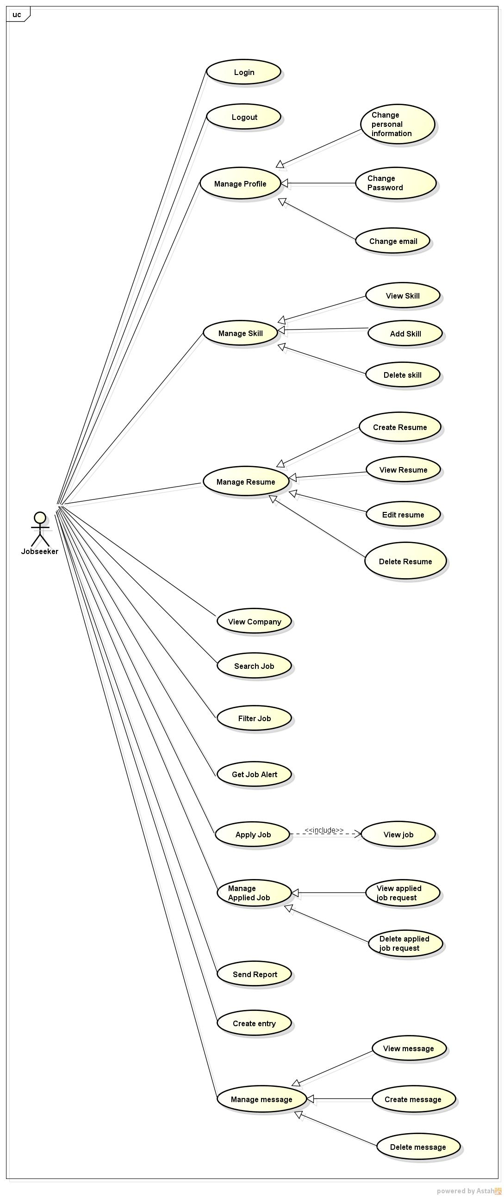

Figure 7: <Job Seekers> Overview Use Case

##### 3.2.2.2.1. <Job Seeker> Register JobSeeker Account

###### 3.2.2.2.1.1. Use case Diagram

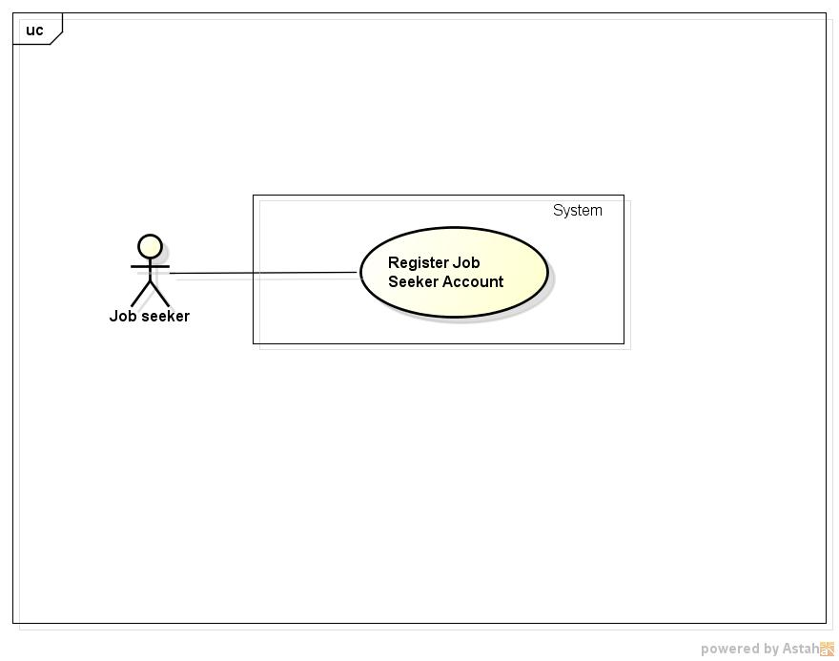

**Figure 8: <Job Seeker>Register Job SeekerAccount Use case Diagram**

###### 3.2.2.1.1.2. Use case Specification

|  |  |  |  |
| --- | --- | --- | --- |
| **USE CASE –006** | | | |
| **Use Case No.** | 006 | **Use Case Version** | 1.0 |
| **Use Case Name** | Register Job Seeker Account | | |
| **Author** | Nguyen Ngoc Thien | | |
| **Date** | 18/05/2015 | **Priority** | High |
| **Actor:**   * Job seeker   **Summary:**   * User register a new jobseeker account by filling personal’s information   **Goal:**   * Register newly a jobseeker account   **Triggers:**   * Click “Đăng ký tài khoản người tìm việc” button on right-top of any page   **Preconditions:**   * Job Searching System page’ s can be displayed normally   **Post Conditions:**   * A new Jobseeker is added to database and auto-login for guest   **Main Success Scenario:**   |  |  |  | | --- | --- | --- | | Step | Actor Action | System Response | | 1 | Click on “Đăng ký tài khoản người tìm việc” button | Redirect to “Đăng ký tài khoản người tìm việc” page contains:   * “Họ” textbox, required. maxlength:16 characters * “Tên” textbox, required, max length: 16 character * “Địa chỉ email” textbox, required, max length:50 characters * “Mật khẩu” textbox, required, min length:6 characters. max length:16 characters. * “Mật khẩu phải từ 6 đến 16 kí tự bao gồm ít nhật 1 chữ hoa, 1 chữ thường và 1 số” text. * “Xác nhận mật khẩu”, textbox,required * “Giới tính” radio button with 2 option “Nam” and “Nữ” * “Quốc tịch” combox contains 152 nations * “Ngày sinh” calendar textbox * “Đăng ký” button * “Hủy” button | | 2 | - Fill information on registration form then click button “Đăng ký” | - Add new Jobseeker account to database  - A success dialog is displayed  - Auto-login for user with registered account and redirect to homepage |   **Alternative Scenario:**   |  |  |  | | --- | --- | --- | | No | Actor Action | System Response | | 1 | At step 2 , user click “Hủy” button instead of “Đăng ký” button | Redirect to Job Searching System homepage |   **Exceptions:**   |  |  |  | | --- | --- | --- | | No | Actor Action | System Response | | 1 | Leave empty on mandatory fields | Auto show error message “Vui lòng nhập thông tin cần thiết” beside mandatory fields | | 2 | Input wrong format for “Địa chỉ email” field and move cursor out of field | Auto show error message “Vui lòng nhập đúng định dạng email. Ví dụ: “abc@gmail.com” | | 3 | Input a used email to “Địa chỉ email” field move cursor out of field | Auto show error message “This email is used. Please input another email” | | 4 | Confirm password is not as password which is entered in ”Mật khẩu” field and move cursor out of field | Auto show error message “Mật khẩu xác nhận phải giống mât khẩu đã nhập” | | 5 | Input information to “Họ” field with length out of valid range | Show error message “Độ dài tối đa không được vượt quá 16 kí tự” | | 6 | Input information to “Tên” field with length out of valid range | Show error message “Độ dài tối đa không được vượt quá 16 kí tự” | | 7 | Input information to “Địa chỉ email” field with length out of valid range | Show error message “Độ dài tối đa không được vượt quá 50 kí tự” | | 8 | Input information to “Mật khẩu” field with length out of valid range | Show error message “Độ dài tối thiểu là 6 kí tự và tối đa không được vượt quá 16 kí tự” | | 9 | Input password to “Mật khẩu” field is not strong enough | Show error message “Mật khẩu phải có ít nhất 1 ký tự hoa, 1 ký tự thường và 1 số” |   **Relationships:**  N/A  **Business Rules:**   * Each email can only register for one jobseeker’ s account. * Password must have at least a uppercase, a lower case and and a number | | | |

##### 3.2.2.2.2. <Job Seeker>Login

###### 3.2.2.2.2.1. Use case Diagram

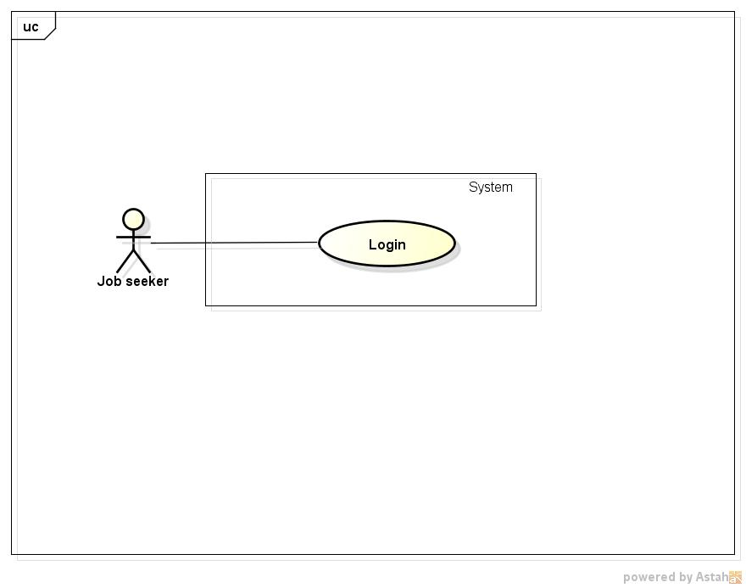

**Figure 9: <Job Seeker>Login Use Case Diagram**

###### 3.2.2.2.2.2. Use case Specification

|  |  |  |  |
| --- | --- | --- | --- |
| **USE CASE –007** | | | |
| **Use Case No.** | 007 | **Use Case Version** | 1.0 |
| **Use Case Name** | Login | | |
| **Author** | Nguyen Ngoc Thien | | |
| **Date** | 18/05/2015 | **Priority** | High |
| **Actor:**   * Job seeker * Recruiter * Manager * Administrator   **Summary:**   * This use case allow user to log into the Job Searching System   **Goal:**   * Log into the Job Searching System with specific role to do functions of that role   **Triggers:**   * Click “Đăng nhập” link on top right of page   **Preconditions:**   * Job Searching System is displayed successfully   **Post Conditions:**   * Login to Job Searching System successully   **Main Success Scenario:**   |  |  |  | | --- | --- | --- | | Step | Actor Action | System Response | | 1 | Click “Đăng nhập” link on top right of page | Redirect to “Đăng nhập” page contains:   * “Email” textbox * “Mật khẩu” textbox * “Đăng nhập” button * “Quên mật khẩu” link * “Đăng ký ngay ” button | | 2 | Fill email and password to field “Email” and “Mật khẩu” then click “Đăng nhập”button | Login to Job Searching System save session for that user and redirect to homepage |   **Alternative Scenario:**   |  |  |  | | --- | --- | --- | | No | Actor Action | System Response | | 1 | Click “Quên mật khẩu” link | Redirect to “Quên mật khẩu” page contains:   * “Email của bạn” textbox * “Reset mật khẩu”button | | 2 | Fill email and click “Reset mật khẩu” button | * System send an email contains a link to reset password for that account message * Display message “Hệ thống đã gửi 1 email giúp bạn reset mật khẩu. Vui lòng kiểm tra hộp thư của bạn” | | 3 | Click “Đăng ký ngay” button | Redirect to “Đăng ký tài khoản người tìm việc” page |   **Exceptions:**   |  |  |  | | --- | --- | --- | | No | Actor Action | System Response | | 1 | Fill unregistered email to “Email” field and click “Đăng nhập ” button | Display error message “Email này chưa được đắng ký với hệ thống” | | 2 | Fill a registered email but wrong password to “Mật khẩu” field and click “Đăng ký” | Display error message “Sai mật khẩu” |   **Relationships:**  N/A  **Business Rules:**   * If user login failed for 5 times consecutive, system will not allow that user login in next 30 minutes | | | |

##### 3.2.2.2.3. <Job Seeker> Logout

###### 3.2.2.2.3.1. Use case Diagram

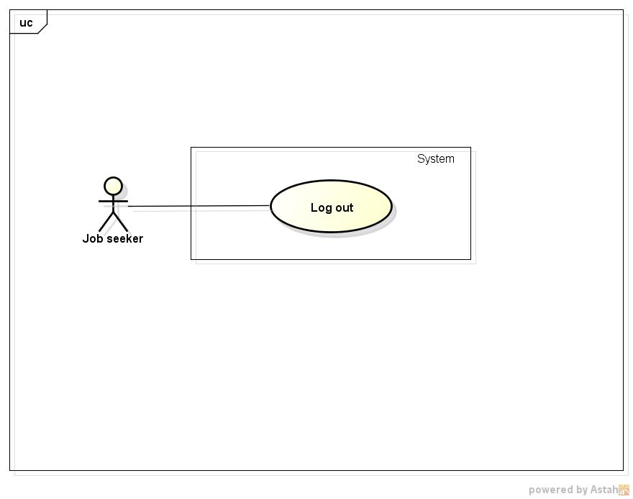

**Figure 10: <Job Seeker>Logout Use Case Diagram**

###### 3.2.2.2.3.2. Use case Specification

|  |  |  |  |
| --- | --- | --- | --- |
| **USE CASE –008** | | | |
| **Use Case No.** | 008 | **Use Case Version** | 1.0 |
| **Use Case Name** | Logout | | |
| **Author** | Nguyen Ngoc Thien | | |
| **Date** | 18/05/2015 | **Priority** | High |
| **Actor:**   * Job seeker * Recruiter * Manager * Administrator   **Summary:**   * This use case allow user to logout of the Job Searching System   **Goal:**   * Logout of the Job Searching System   **Triggers:**   * Click “Đăng xuất” itemin drop down menu of user   **Preconditions:**   * Job Searching System is displayed successfully   **Post Conditions:**   * Logout of Job Searching System successfully   **Main Success Scenario:**   |  |  |  | | --- | --- | --- | | Step | Actor Action | System Response | | 1 | Click “Đăng xuất” itemon drop down menu of user | * Delete session of that user * Redirect to home page |   **Alternative Scenario:**  N/A  **Exceptions:**  N/A  **Relationships:**  N/A  **Business Rules:**  N/A | | | |

##### 3.2.2.2.4. <Job Seeker> Change Personal Information

###### 3.2.2.2.4.1. Use case Diagram

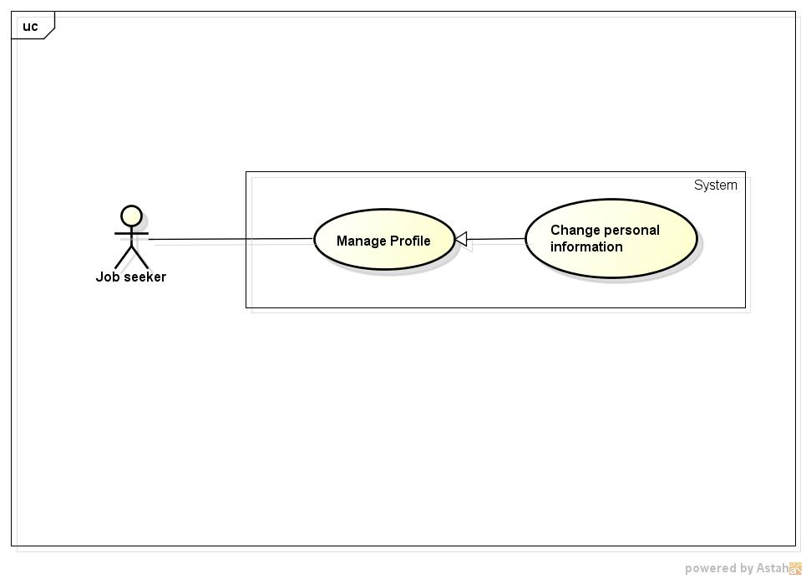

**Figure 11: <Job Seeker>Change Personal Information Use case Diagram**

###### 3.2.2.2.4.2. Use case Specification

|  |  |  |  |
| --- | --- | --- | --- |
| **USE CASE –009** | | | |
| **Use Case No.** | 009 | **Use Case Version** | 1.0 |
| **Use Case Name** | Change personal information | | |
| **Author** | Nguyen Ngoc Thien | | |
| **Date** | 18/05/2015 | **Priority** | High |
| **Actor:**   * Job Seeker * Manager * Administrator   **Summary:**   * This use case allow user to change personal information   **Goal:**   * Allow user update their personal information   **Triggers:**   * Click drop down menu beside username text on top right of page, then select “Tài khoản” item   **Preconditions:**   * User login successfully   **Post Conditions:**   * Personal information on profile is updated   **Main Success Scenario:**   |  |  |  | | --- | --- | --- | | Step | Actor Action | System Response | | 1 | Select “Tài khoản” item from user’s drop down menu | Redirect to “Thông tin cá nhân” page contain:   * **“Thông tin cá nhân” block** * “Họ” textbox, required. maxlength:16 characters * “Tên” textbox, required, max length: 16 character * “Địa chỉ email” textbox, required, max length:50 characters * “Mật khẩu” textbox, required, min length:6 characters. max length:16 characters. * “Mật khẩu phải từ 6 đến 16 kí tự bao gồm ít nhật 1 chữ hoa, 1 chữ thường và 1 số” text. * “Xác nhận mật khẩu”, textbox,required * “Giới tính” radio button with 2 option “Nam” and “Nữ” * “Quốc tịch” combox contains 152 nations * “Ngày sinh” calendar textbox * “Lưu” button * **“Đổi mật khẩu” block** * “Mật khẩu hiện tại” textbox,required * “Mật khẩu mới” textbox, min length:6 characters, max length:16 characters. * “Mật khẩu phải từ 6 đến 16 kí tự bao gồm ít nhật 1 chữ hoa, 1 chữ thường và 1 số” text. * “Xác nhận mật khẩu mới” textbox, required * “Lưu” button * “**Đổi email truy cập” block** * “Email hiện tại” text, display current email * “Xác nhận mật khẩu” text box, required * “Nhập email truy cập mới” textbox, required, max length:50 characters * “Xác nhận email mới” textbox, required * “Lưu” button | | 2 | Update personal information click “Lưu” button in “Thông tin cá nhân” block | -Find user’s account in database that match with current user’s account  - Update personal information of that account in database |   **Alternative Scenario:**  N/A  **Exceptions:**   |  |  |  | | --- | --- | --- | | No | Actor Action | System Response | | 1 | User leave empty on mandatory fields then click “Lưu” button | Show error message “Vui lòng nhập thông tin cần thiết” beside mandatory fields | | 2 | Input information to “Họ” field with length out of valid range | Show error message “Độ dài tối đa không được vượt quá 16 kí tự” | | 3 | Input information to “Địa chỉ email” field with length out of valid range | Show error message “Độ dài tối đa không được vượt quá 50 kí tự” | | 4 | Input information to “Tên” field with length out of valid range | Show error message “Độ dài tối đa không được vượt quá 16 kí tự” |   **Relationships:**   * Login   **Business Rules:**   * When update password and email in “Thông tin cá nhân” page user must input correctly their current password * Each email can only register for one jobseeker’s account. * Password must have at least a uppercase, a lower case and and a number | | | |

##### 3.2.2.2.5. <Job Seekers> Change Password

###### 3.2.2.2.5.1. Use case Diagram

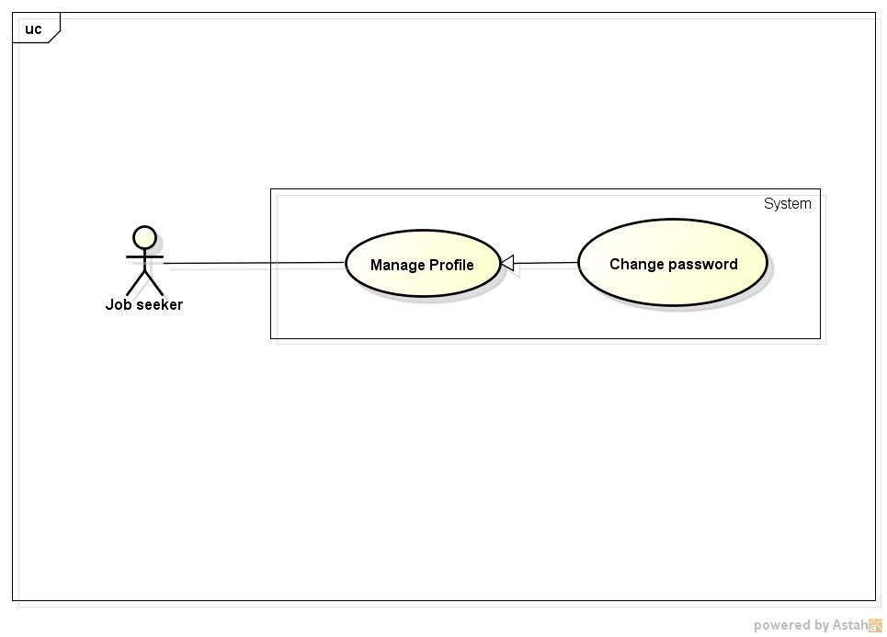

**Figure 12: <Job Seekers>Change Password Use Case Diagram**

###### 3.2.2.2.5.2. Use case Specification

|  |  |  |  |
| --- | --- | --- | --- |
| **USE CASE –010** | | | |
| **Use Case No.** | 001 | **Use Case Version** | 1.0 |
| **Use Case Name** | Edit profile | | |
| **Author** | Nguyen Ngoc Thien | | |
| **Date** | 18/05/2015 | **Priority** | High |
| **Actor:**   * Job Seeker * Manager * Administrator   **Summary:**   * This use case allow user to change password   **Goal:**   * Allow user update their current passsword   **Triggers:**   * Click drop down menu beside username text on top right of page, then select “Tài khoản” item   **Preconditions:**   * User login successfully   **Post Conditions:**   * Password is updated   **Main Success Scenario:**   |  |  |  | | --- | --- | --- | | Step | Actor Action | System Response | | 1 | Select “Tài khoản” item from user’s drop down menu | Redirect to “Thông tin cá nhân” page contain:   * **“Thông tin cá nhân” block** * “Họ” textbox, required. maxlength:16 characters * “Tên” textbox, required, max length: 16 character * “Địa chỉ email” textbox, required, max length:50 characters * “Mật khẩu” textbox, required, min length:6 characters. max length:16 characters. * “Mật khẩu phải từ 6 đến 16 kí tự bao gồm ít nhật 1 chữ hoa, 1 chữ thường và 1 số” text. * “Xác nhận mật khẩu”, textbox,required * “Giới tính” radio button with 2 option “Nam” and “Nữ” * “Quốc tịch” combox contains 152 nations * “Ngày sinh” calendar textbox * “Lưu” button * **“Đổi mật khẩu” block** * “Mật khẩu hiện tại” textbox,required * “Mật khẩu mới” textbox, min length:6 characters, max length:16 characters. * “Mật khẩu phải từ 6 đến 16 kí tự bao gồm ít nhật 1 chữ hoa, 1 chữ thường và 1 số” text. * “Xác nhận mật khẩu mới” textbox, required * “Lưu” button * “**Đổi email truy cập” block** * “Email hiện tại” text, display current email * “Xác nhận mật khẩu” text box, required * “Nhập email truy cập mới” textbox, required, max length:50 characters * “Xác nhận email mới” textbox, required * “Lưu” button | | 2 | Fill current password to “Mật khẩu hiện tại” textbox, new password to “Mật khẩu mới ” textbox and confirm password to “Xác nhận mật khẩu mới” textbox then click button “Lưu” | -Find user’s account in database that match with current user’s account  - Update new password for that user’ s account |   **Alternative Scenario:**  N/A  **Exceptions:**   |  |  |  | | --- | --- | --- | | No | Actor Action | System Response | | 1 | User leave empty on mandatory fields then click “Lưu” button | Show error message “Vui lòng nhập thông tin cần thiết” beside mandatory fields | | 2 | In “Đổi mật khẩu” block , input a wrong password for field “Mật khẩu hiện tại” then click “Lưu” button | Show error message “Mật khẩu hiện tại không đúng” besides “Mật khẩu hiện tại” textbox | | 3 | Input confirm password is not as password which is entered in ”Mật khẩu” textboxto “Xác nhận mật khẩu mới” textbox and move cursor out of field | Auto show error message “Mật khẩu xác nhận phải giống mât khẩu đã nhập” | | 4 | Input password to “Mật khẩu” field is not strong enough and move cursor out of field | Show error message “Mật khẩu phải có ít nhất 1 ký tự hoa, 1 ký tự thường và 1 số” |   **Relationships:**   * Login   **Business Rules:**   * When update password user must input correctly their current password * Password must have at least a uppercase, a lower case and and a number | | | |

##### 3.2.2.2.6. <Job Seeker> Change Email

###### 3.2.2.2.6.1. Use case Diagram

**Figure 13: <Job Seeker>Change Email Use Case Diagram**

###### 3.2.2.2.6.2. Use case Specification

|  |  |  |  |
| --- | --- | --- | --- |
| **USE CASE –011** | | | |
| **Use Case No.** | 011 | **Use Case Version** | 1.0 |
| **Use Case Name** | Change email | | |
| **Author** | Nguyen Ngoc Thien | | |
| **Date** | 18/05/2015 | **Priority** | High |
| **Actor:**   * Job Seeker * Manager * Administrator   **Summary:**   * This use case allow user to change email   **Goal:**   * Allow user update their email   **Triggers:**   * Click drop down menu beside username text on top right of page, then select “Tài khoản” item   **Preconditions:**   * User login successfully   **Post Conditions:**   * Email is updated   **Main Success Scenario:**   |  |  |  | | --- | --- | --- | | Step | Actor Action | System Response | | 1 | Select “Tài khoản” item from user’s drop down menu | Redirect to “Thông tin cá nhân” page contain:   * **“Thông tin cá nhân” block** * “Họ” textbox, required. maxlength:16 characters * “Tên” textbox, required, max length: 16 character * “Địa chỉ email” textbox, required, max length:50 characters * “Mật khẩu” textbox, required, min length:6 characters. max length:16 characters. * “Mật khẩu phải từ 6 đến 16 kí tự bao gồm ít nhật 1 chữ hoa, 1 chữ thường và 1 số” text. * “Xác nhận mật khẩu”, textbox,required * “Giới tính” radio button with 2 option “Nam” and “Nữ” * “Quốc tịch” combox contains 152 nations * “Ngày sinh” calendar textbox * “Lưu” button * **“Đổi mật khẩu” block** * “Mật khẩu hiện tại” textbox,required * “Mật khẩu mới” textbox, min length:6 characters, max length:16 characters. * “Mật khẩu phải từ 6 đến 16 kí tự bao gồm ít nhật 1 chữ hoa, 1 chữ thường và 1 số” text. * “Xác nhận mật khẩu mới” textbox, required * “Lưu” button * “**Đổi email truy cập” block** * “Email hiện tại” text, display current email * “Xác nhận mật khẩu” text box, required * “Nhập email truy cập mới” textbox, required, max length:50 characters * “Xác nhận email mới” textbox, required * “Lưu” button | | 2 | * Fill current password to “Xác nhận mật khẩu” text box * Fill new email to “Nhập email truy cập mới” textbox * Retype new email to “Xác nhận email mới” textbox * Click “Lưu” button | -Find user’s account in database that match with current user’s account  - Updateemail of that account in database |   **Alternative Scenario:**  N/A  **Exceptions:**   |  |  |  | | --- | --- | --- | | No | Actor Action | System Response | | 1 | User leave empty on mandatory fields then click “Lưu” button | Show error message “Vui lòng nhập thông tin cần thiết” beside mandatory fields | | 2 | In “Đổi mật khẩu” block , input a wrong password for field “Xác nhận mật khẩu” then click “Lưu” button | Show error message “Mật khẩu hiện tại không đúng” besides “Mật khẩu hiện tại” textbox | | 3 | In “Đổi email truy cập” block , input a wrong password for field “Mật khẩu hiện tại” then click “Lưu” button | Show error message “Mật khẩu hiện tại không đúng” besides “Xác nhận mật khẩu” textbox | | 2 | Input wrong format for “Địa chỉ email” field and move cursor out of field | Auto show error message “Vui lòng nhập đúng định dạng email. Ví dụ: “abc@gmail.com” | | 3 | Input a used email to “Địa chỉ email” field move cursor out of field | Auto show error message “This email is used. Please input another email” | | 4 | Confirm password is not as password which is entered in ”Mật khẩu” field and move cursor out of field | Auto show error message “Mật khẩu xác nhận phải giống mât khẩu đã nhập” | | 5 | Input information to “Họ” field with length out of valid range | Show error message “Độ dài tối đa không được vượt quá 16 kí tự” | | 6 | Input information to “Địa chỉ email” field with length out of valid range | Show error message “Độ dài tối đa không được vượt quá 50 kí tự” | | 7 | Input information to “Mật khẩu” field with length out of valid range | Show error message “Độ dài tối thiểu là 6 kí tự và tối đa không được vượt quá 16 kí tự” | | 8 | Input password to “Mật khẩu” field is not strong enough | Show error message “Mật khẩu phải có ít nhất 1 ký tự hoa, 1 ký tự thường và 1 số” | | 9 | Input information to “Tên” field with length out of valid range | Show error message “Độ dài tối đa không được vượt quá 16 kí tự” |   **Relationships:**   * Login   **Business Rules:**   * When update email in user must input correctly their current password * Each email can only register for one jobseeker’s account. | | | |

##### 3.2.2.2.7. <Job Seeker> View Skills

###### 3.2.2.2.7.1. Use case Diagram

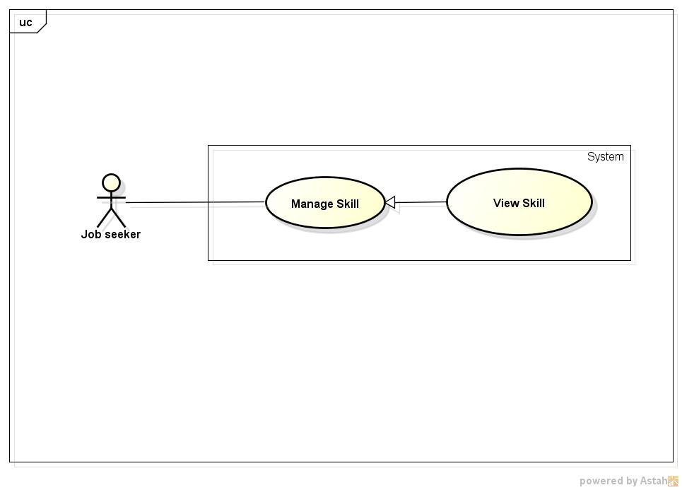

**Figure 14: <Job Seeker>View Skill Use Case Diagram**

###### 3.2.2.2.7.2. Use case Specification

|  |  |  |  |
| --- | --- | --- | --- |
| **USE CASE –012** | | | |
| **Use Case No.** | 012 | **Use Case Version** | 1.0 |
| **Use Case Name** | View skills | | |
| **Author** | Nguyen Ngoc Thien | | |
| **Date** | 18/05/2015 | **Priority** | High |
| **Actor:**   * Job Seeker   **Summary:**   * This use case allow user to view skills   **Goal:**   * View skill tags   **Triggers:**   * Click “Thêm kĩ năng” item in drop down menu of job seeker   **Preconditions:**   * Login successfully with role Job seeker   **Post Conditions:**   * Display a list of skill tags or no tags is displayed   **Main Success Scenario:**   |  |  |  | | --- | --- | --- | | Step | Actor Action | System Response | | 1 | Click “Thêm kĩ năng” item on drop down menu of job seeker | Redirect to “Kỹ năng của tôi” page contains:   * A block contains skill tags * “Kĩ năng” textbox, required with “Thêm” button beside * “Lưu” button and “Hủy” button |   **Alternative Scenario:**  **N/A**  **Exceptions:**  **N/A**  **Relationships:**   * Login   **Business Rules:**  **N/A** | | | |

##### 3.2.2.2.8. <Job Seeker> Add Skill

###### 3.2.2.2.8.1. Use case Diagram

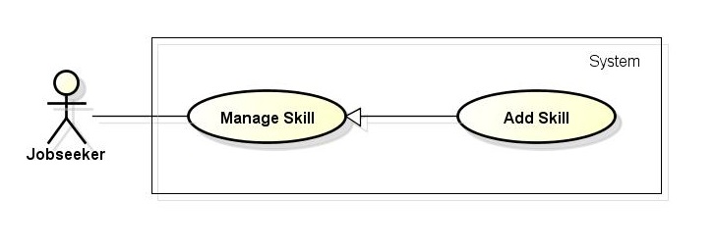

**Figure 15: <Job Seekers>Search Jobs Use case Diagram**

###### 3.2.2.2.8.2. Use case Specification

|  |  |  |  |
| --- | --- | --- | --- |
| **USE CASE –013** | | | |
| **Use Case No.** | 013 | **Use Case Version** | 1.0 |
| **Use Case Name** | Add skill | | |
| **Author** | Nguyen Ngoc Thien | | |
| **Date** | 18/05/2015 | **Priority** | High |
| **Actor:**   * Job Seeker   **Summary:**   * This use case allow user to add skill to get more job recommendation   **Goal:**   * Add skill information to job seeker   **Triggers:**   * Click “Thêm kĩ năng” item in drop down menu of job seeker * System will redirect to “Kỹ năng của tôi” page, then fill name of skill in textbox then click ”Thêm” button to create a skill tag then click button save to add all those skill tags   **Preconditions:**   * Login successfully with role Job seeker   **Post Conditions:**   * Add skill tags to job seeker’s information   **Main Success Scenario:**   |  |  |  | | --- | --- | --- | | Step | Actor Action | System Response | | 1 | Click “Thêm kĩ năng” item on drop down menu of job seeker | Redirect to “Kỹ năng của tôi” page contains:   * A block contains skill tags * “Kĩ năng” textbox, required with “Thêm” button beside * “Lưu” button and “Hủy” button | | 2 | Fill name of skill then click button “Thêm” | Create a skill tag then add to skill block | | 3 | Click “Lưu” button | Save all skill tags to job seeker’s information |   **Alternative Scenario:**  **N/A**  **Exceptions:**  **N/A**  **Relationships:**   * Login   **Business Rules:**  **N/A** | | | |

##### 3.2.2.2.9. <Job Seeker> Delete Skill

###### 3.2.2.2.9.1. Use case Diagram

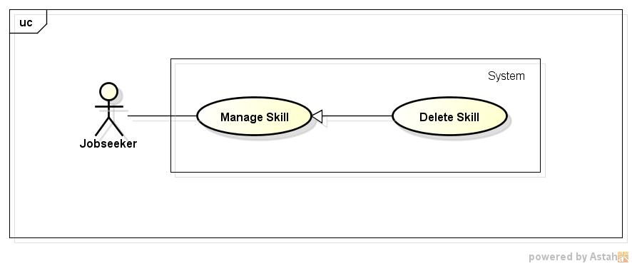

**Figure 16: <Job Seeker>Delete Skill Use Case Diagram**

###### 3.2.2.2.9.2. Use case Specification

|  |  |  |  |
| --- | --- | --- | --- |
| **USE CASE –014** | | | |
| **Use Case No.** | 014 | **Use Case Version** | 1.0 |
| **Use Case Name** | Delete skill | | |
| **Author** | Nguyen Ngoc Thien | | |
| **Date** | 18/05/2015 | **Priority** | High |
| **Actor:**   * Job Seeker   **Summary:**   * This use case allow user to delete skill tags   **Goal:**   * Delete skill tags   **Triggers:**   * Click “Thêm kĩ năng” item in drop down menu of job seeker * System will redirect to “Kỹ năng của tôi” page, then click delete icon on skill tag to delete that skill after that click button save to update skill tags to job seeker’s information   **Preconditions:**   * Login successfully with role Job seeker * Have at least a skill tag on “Kĩ năng của tôi” page   **Post Conditions:**   * Delete skill tags that job seeker want to remove   **Main Success Scenario:**   |  |  |  | | --- | --- | --- | | Step | Actor Action | System Response | | 1 | Click “Thêm kĩ năng” item on drop down menu of job seeker | Redirect to “Kỹ năng của tôi” page contains:   * A block contains skill tags * “Kĩ năng” textbox, required with “Thêm” button beside * “Lưu” button and “Hủy” button | | 2 | Click delete icon on skill tag that want to remove | Remove skill tags | | 3 | Click “Lưu” button | Update skill tags to jobseeker ‘s information |   **Alternative Scenario:**  **N/A**  **Exceptions:**  **N/A**  **Relationships:**   * Login   **Business Rules:**  **N/A** | | | |

##### 3.2.2.2.10. <Job Seeker> Create Resume

###### 3.2.2.2.10.1. Use case Diagram

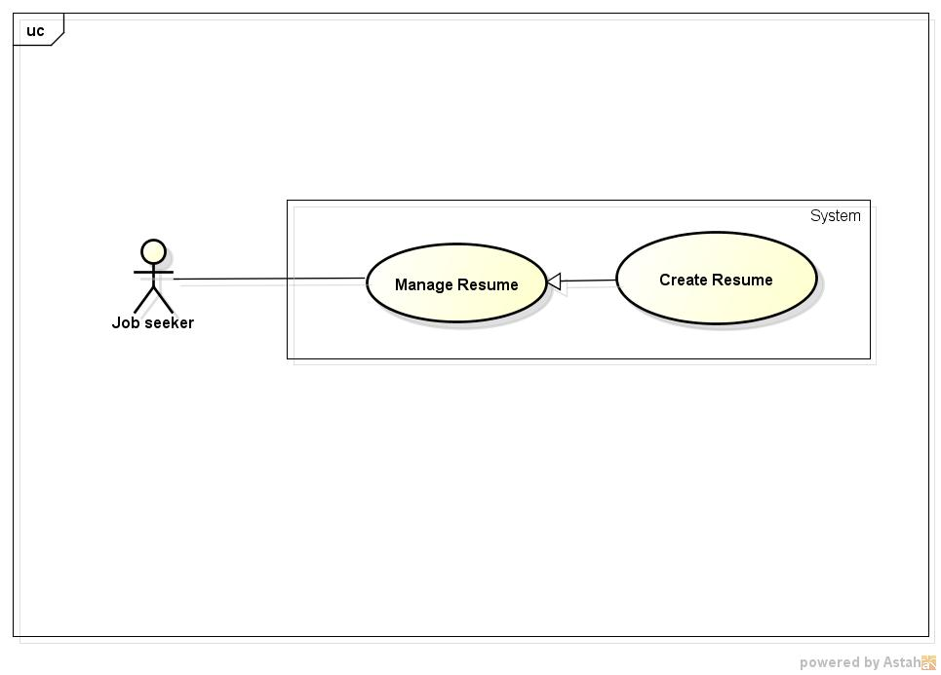

**Figure 17: <Job Seeker>Create Resume Use Case Diagram**

###### 3.2.2.2.10.2. Use case Specification

|  |  |  |  |
| --- | --- | --- | --- |
| **USE CASE –015** | | | |
| **Use Case No.** | 015 | **Use Case Version** | 1.0 |
| **Use Case Name** | Create Resume | | |
| **Author** | Nguyen Ngoc Thien | | |
| **Date** | 18/05/2015 | **Priority** | High |
| **Actor:**   * Job Seeker   **Summary:**   * This use case allow user to create a resume which recruiter will see when job seeker apply any job.   **Goal:**   * Create job seeker ‘s resume   **Triggers:**   * Click drop down menu beside username text on top right of page, then select “Tạo hồ sơ” item   **Preconditions:**   * User login successfully with role Job Seeker   **Post Conditions:**   * A resume is created and send to Manager for censorship   **Main Success Scenario:**   |  |  |  | | --- | --- | --- | | Step | Actor Action | System Response | | 1 | Select “Tạo hồ sơ” item from user’s drop down menu | Redirect to “Tạo hồ sơ” page contains:  **- “Thông tin cá nhân” block:**   * “Ngày sinh” textbox that display a calendar when focus, date format: dd/mm/yyyy, required * “Tình trạng hôn nhân” radio button with 2 option “Married” and “Single” * “Địa chỉ” textbox, min length:0. Max length:50 * “Quốc gia” combo box, contains 152 nations, required * “Giới tính” radio button with 2 option “Male” and “Female”, required * “Thành phố/Tỉnh” combo box, contains all city and province of selected country, required * “Điện thoại di động” textbox, min length:8 max length:16, required   **- “Summary” block :**   * “Kinh nghiệm” textbox with “Mới tốt nghiệp chưa có kinh nghiệm” checkbox beside, only number allowed, min length:1, max length: 3, required.   If checkbox is checked, textbox will be disabled, required   * “Bằng cấp cao nhất” combo box, contains item below: * Trung học * Trung cấp * Cao đẳng * Cử nhân * Kỹ sư * Kế toán viên công chứng * Thạc sĩ * Thạc sĩ quản trị kinh doanh * Tiến sĩ luật * Tiến sĩ * Dược sĩ * Dược sĩ y khoa * Khác * “Ngoại ngữ” combo box contains all language with “Add more” button, when user click add more, system will insert a more combo box for “Language” field, required * “Trình độ” combo box with 4 items below: * Sơ cấp * Trung cấp * Cao cấp * Bản ngữ * “Công ty gần đây nhất ” textbox, minlength:0 , max length:50 * “Vị trí gần đây nhất” textbox, min length:0, max length:50 * “Vị trí mong muốn” textbox, min length: 0, max length:50, required * “Nơi làm việc mong muốn” textbox, minlength:0, max length:50, required * “Mức lương mong muốn radio button with 2 options “Thỏa thuận” and “USD/tháng” with textbox beside, required. If user choose “USD/month” radio button textbox can be inputted otherwise it is disable ,   - **“Hồ sơ/Mục tiêu nghề nghiệp” block:**   * “Giới thiệu bản thân và mô tả mục tiêu nghề nghiệp của bạn” text area, min length:10, max length: 5000, required   **- “Kinh nghiệm làm việc” block:**   * “Vị trí” textbox, min length:3, max length:50, required * “Công ty” textbox, min length:3, max length:50, required * “Từ tháng” textbox that display a calendar when focus * “Đếm tháng” textbox that display a calendar when focus * “Mô tả” text area, min length: 10 , max length: 5000   **- “Học vấn và bằng cấp” block:**   * “Chuyên nghành” textbox, min length:5, max length: 50, required * “Trường” textbox, min length:5, max length: 50, required * “Bằng cấp” combo box , required ,will contains item below: * Trung học * Trung cấp * Cao đẳng * Cử nhân * Kỹ sư * Kế toán viên công chứng * Thạc sĩ * Thạc sĩ quản trị kinh doanh * Tiến sĩ luật * Tiến sĩ * Dược sĩ * Dược sĩ y khoa * Khác * “Thành tựu” text area, min length:10, max length:5000   **- “**Tạo**”** button, “Hủy” button | | 2 | Enter information to field and click “Tạo” button | - A new resume for that job’s seeker is inserted to database  - Send job seeker’s resume to Manager for censorship  - Redirect to “Quản lý hồ sơ” page |   **Alternative Scenario:**   |  |  |  | | --- | --- | --- | | No | Actor Action | System Response | | 1 | At step 2, user click “Hủy” button instead of “Tạo” button | Redirect to Job Searching System homepage |   **Exceptions:**   |  |  |  | | --- | --- | --- | | No | Actor Action | System Response | | 1 | User leave empty on mandatory fields then click “Tạo” button | Show error message “Vui lòng nhập thông tin cần thiết” beside mandatory fields | | 2 | Input information to “Địa chỉ” field with length out of valid range | Show error message “Độ dài tối đa không được vượt quá 50 kí tự” | | 3 | Input information to “Cell number” field with length out of valid range | Show error message “Độ dài tối thiều là 6 và độ dài tối đá không được vượt quá 16 kí tự” | | 4 | Input year to “Kinh nghiệm” field with length out of valid range | Show error message “Độ dài tối thiều là 1 và độ dài tối đá không được vượt quá 3 kí tự” | | 5 | Input information to “Vị trí gần đây nhất” field with length out of valid range | Show error message “Độ dài tối đa không được vượt quá 50 kí tự” | | 6 | Input information to “Vị trí mong muốn” field with length out of valid range | Show error message “Độ dài tối đa không được vượt quá 50 kí tự” | | 7 | Input information to “Nơi làm việc” field with length out of valid range | Show error message “Độ dài tối đa không được vượt quá 50 kí tự” | | 8 | Input information to “Giới thiệu bản thân và mô tả mục tiêu nghề nghiệp của bạn” field with length out of valid range | Show error message “Độ dài tối thiều là 10 và độ dài tối đá không được vượt quá 1000 kí tự” | | 9 | Input information to “Vị trí” field with length out of valid range | Show error message “Độ dài tối thiều là 3 và độ dài tối đá không được vượt quá 50 kí tự” | | 10 | Input information to “Công ty” field with length out of valid range | Show error message “Độ dài tối thiều là 3 và độ dài tối đá không được vượt quá 50 kí tự” | | 11 | Input information to “Mô tả” field with length out of valid range | Show error message “Độ dài tối thiều là 10 và độ dài tối đá không được vượt quá 1000 kí tự” | | 12 | Input information to “Chuyên nghành” field with length out of valid range | Show error message “Độ dài tối thiều là 5 và độ dài tối đá không được vượt quá 50 kí tự” | | 12 | Input information to “Trường học” field with length out of valid range | Show error message “Length must be in range from 5 to 50” | | 13 | Input information to “Thành tựu” field with length out of valid range | Show error message “Độ dài tối thiều là 10 và độ dài tối đá không được vượt quá 5000 kí tự” |   **Relationships:**   * Login   **Business Rules:**   * Job seeker’s resume must be censored before public for recruiter view and using for job suggestion | | | |

##### 3.2.2.2.11. <Job Seeker> Edit Resume

###### 3.2.2.2.11.1. Use case Diagram

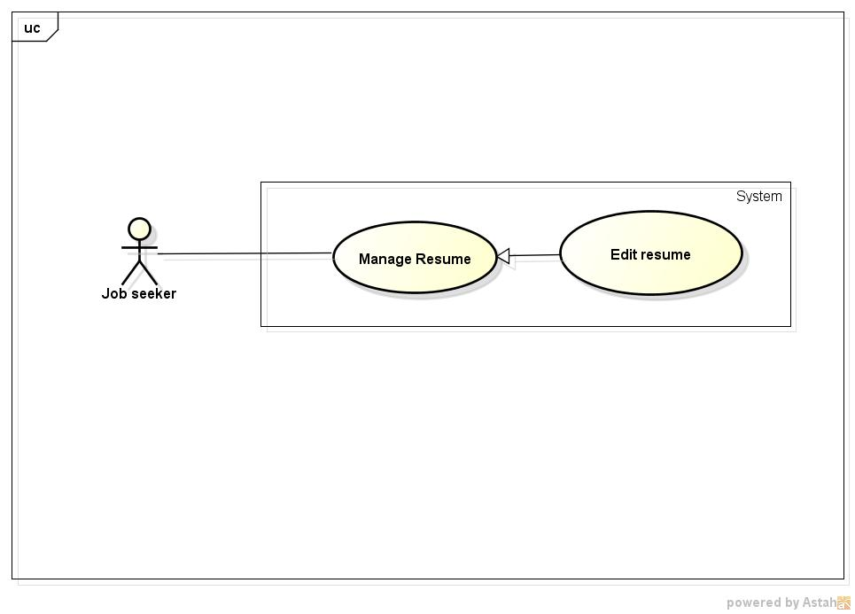

**Figure 18: <Job Seeker>Edit Resume Use Case Diagram**

###### 3.2.2.2.11.2. Use case Specification

|  |  |  |  |
| --- | --- | --- | --- |
| **USE CASE –016** | | | |
| **Use Case No.** | 016 | **Use Case Version** | 1.0 |
| **Use Case Name** | Edit Resume | | |
| **Author** | Nguyen Ngoc Thien | | |
| **Date** | 18/05/2015 | **Priority** | High |
| **Actor:**   * Job Seeker   **Summary:**   * This use case allow user to edit resume   **Goal:**   * Update information on job’s seeker resume   **Triggers:**   * Click dropdown menu of user then select “Quản lý hồ sơ” item * In “Quản lý hồ sơ” page will display a list of resume , job seeker click “Sửa” link on same line with resume that want to edit   **Preconditions:**   * User login successfully with role Job Seeker * “Quản lý hồ sơ” page display successfully   **Post Conditions:**   * Resume is Updated and send to Manager for censorship   **Main Success Scenario:**   |  |  |  | | --- | --- | --- | | Step | Actor Action | System Response | | 1 | Select “Quản lý hồ sơ” item from user’s drop down menu | Redirect to “Quản lý hồ sơ” page contains: | | 2 | Select “Sửa” link with same line with resume that want to edit | Redirect to “Cập nhật hồ sơ” page contains:  **- “Thông tin cá nhân” block:**   * “Ngày sinh” textbox that display a calendar when focus, date format: dd/mm/yyyy, required * “Tình trạng hôn nhân” radio button with 2 option “Married” and “Single” * “Địa chỉ” textbox, min length:0. Max length:50 * “Quốc gia” combo box, contains 152 nations, required * “Giới tính” radio button with 2 option “Male” and “Female”, required * “Thành phố/Tỉnh” combo box, contains all city and province of selected country, required * “Điện thoại di động” textbox, min length:8 max length:16, required   **- “Summary” block :**   * “Kinh nghiệm” textbox with “Mới tốt nghiệp chưa có kinh nghiệm” checkbox beside, only number allowed, min length:1, max length: 3, required.   If checkbox is checked, textbox will be disabled, required   * “Bằng cấp cao nhất” combo box, contains item below: * Trung học * Trung cấp * Cao đẳng * Cử nhân * Kỹ sư * Kế toán viên công chứng * Thạc sĩ * Thạc sĩ quản trị kinh doanh * Tiến sĩ luật * Tiến sĩ * Dược sĩ * Dược sĩ y khoa * Khác * “Ngoại ngữ” combo box contains all language with “Add more” button, when user click add more, system will insert a more combo box for “Language” field, required * “Trình độ” combo box with 4 items below: * Sơ cấp * Trung cấp * Cao cấp * Bản ngữ * “Công ty gần đây nhất ” textbox, minlength:0 , max length:50 * “Vị trí gần đây nhất” textbox, min length:0, max length:50 * “Vị trí mong muốn” textbox, min length: 0, max length:50, required * “Nơi làm việc mong muốn” textbox, minlength:0, max length:50, required * “Mức lương mong muốn radio button with 2 options “Thỏa thuận” and “USD/tháng” with textbox beside, required. If user choose “USD/month” radio button textbox can be inputted otherwise it is disable ,   - **“Hồ sơ/Mục tiêu nghề nghiệp” block:**   * “Giới thiệu bản thân và mô tả mục tiêu nghề nghiệp của bạn” text area, min length:10, max length: 5000, required   **- “Kinh nghiệm làm việc” block:**   * “Vị trí” textbox, min length:3, max length:50, required * “Công ty” textbox, min length:3, max length:50, required * “Từ tháng” textbox that display a calendar when focus * “Đếm tháng” textbox that display a calendar when focus * “Mô tả” text area, min length: 10 , max length: 5000   **- “Học vấn và bằng cấp” block:**   * “Chuyên nghành” textbox, min length:5, max length: 50, required * “Trường” textbox, min length:5, max length: 50, required * “Bằng cấp” combo box , required ,will contains item below: * Trung học * Trung cấp * Cao đẳng * Cử nhân * Kỹ sư * Kế toán viên công chứng * Thạc sĩ * Thạc sĩ quản trị kinh doanh * Tiến sĩ luật * Tiến sĩ * Dược sĩ * Dược sĩ y khoa * Khác * “Thành tựu” text area, min length:10, max length:5000   **- “**Lưu**”** button, “Hủy” button | | 3 | Enter information to field and click “Lưu” button | - Access to database and update field of resume  - Send job seeker’s updated resume to Manager for censorship  - Redirect to “Quản lý hồ sơ” page |   **Alternative Scenario:**   |  |  |  | | --- | --- | --- | | No | Actor Action | System Response | | 1 | At step 2, user click “Hủy” button instead of “Lưu” button | Redirect to “Quản lý hồ sơ” page |   **Exceptions:**   |  |  |  | | --- | --- | --- | | No | Actor Action | System Response | | 1 | User leave empty on mandatory fields then click “Lưu” button | Show error message “Vui lòng nhập thông tin cần thiết” beside mandatory fields | | 2 | Input information to “Địa chỉ” field with length out of valid range | Show error message “Độ dài tối đa không được vượt quá 50 kí tự” | | 3 | Input information to “Cell number” field with length out of valid range | Show error message “Độ dài tối thiều là 6 và độ dài tối đá không được vượt quá 16 kí tự” | | 4 | Input year to “Kinh nghiệm” field with length out of valid range | Show error message “Độ dài tối thiều là 1 và độ dài tối đá không được vượt quá 3 kí tự” | | 5 | Input information to “Vị trí gần đây nhất” field with length out of valid range | Show error message “Độ dài tối đa không được vượt quá 50 kí tự” | | 6 | Input information to “Vị trí mong muốn” field with length out of valid range | Show error message “Độ dài tối đa không được vượt quá 50 kí tự” | | 7 | Input information to “Nơi làm việc” field with length out of valid range | Show error message “Độ dài tối đa không được vượt quá 50 kí tự” | | 8 | Input information to “Giới thiệu bản thân và mô tả mục tiêu nghề nghiệp của bạn” field with length out of valid range | Show error message “Độ dài tối thiều là 10 và độ dài tối đá không được vượt quá 1000 kí tự” | | 9 | Input information to “Vị trí” field with length out of valid range | Show error message “Độ dài tối thiều là 3 và độ dài tối đá không được vượt quá 50 kí tự” | | 10 | Input information to “Công ty” field with length out of valid range | Show error message “Độ dài tối thiều là 3 và độ dài tối đá không được vượt quá 50 kí tự” | | 11 | Input information to “Mô tả” field with length out of valid range | Show error message “Độ dài tối thiều là 10 và độ dài tối đá không được vượt quá 1000 kí tự” | | 12 | Input information to “Chuyên nghành” field with length out of valid range | Show error message “Độ dài tối thiều là 5 và độ dài tối đá không được vượt quá 50 kí tự” | | 12 | Input information to “Trường học” field with length out of valid range | Show error message “Độ dài tối thiều là 5 và độ dài tối đá không được vượt quá 50 kí tự” | | 13 | Input information to “Thành tựu” field with length out of valid range | Show error message “Độ dài tối thiều là 10 và độ dài tối đá không được vượt quá 5000 kí tự” |   **Relationships:**   * Login   **Business Rules:**   * Job seeker’s resume after updating must be censored before public for recruiter view and using for job suggestion | | | |

##### 3.2.2.2.12. <Job Seeker> Delete Resume

###### 3.2.2.2.12.1. Use case Diagram

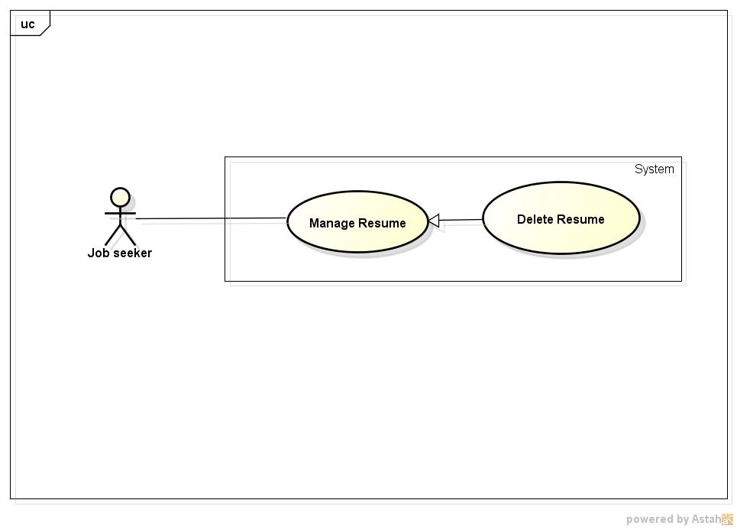

**Figure 19: <Job Seeker>Delete Resume Use Case Diagram**

###### 3.2.2.2.12.2. Use case Specification

|  |  |  |  |
| --- | --- | --- | --- |
| **USE CASE –017** | | | |
| **Use Case No.** | 017 | **Use Case Version** | 1.0 |
| **Use Case Name** | Delete Resume | | |
| **Author** | Nguyen Ngoc Thien | | |
| **Date** | 18/05/2015 | **Priority** | High |
| **Actor:**   * Job Seeker   **Summary:**   * This use case allow user to delete resume   **Goal:**   * Delete a resume of job seeker   **Triggers:**   * Click dropdown menu of user then select “Quản lý hồ sơ” item * In “Quản lý hồ sơ” page will display a list of resume , job seeker click “Xóa” link on same line with resume that want to delete   **Preconditions:**   * User login successfully with role Job Seeker * “Quản lý hồ sơ” page display successfully   **Post Conditions:**   * Selected resume is deleted   **Main Success Scenario:**   |  |  |  | | --- | --- | --- | | Step | Actor Action | System Response | | 1 | Select “Quản lý hồ sơ” item from user’s drop down menu | Redirect to “Quản lý hồ sơ” page contains: | | 2 | Select “Xóa” link with same line with resume that want to edit | - Display delete confirm dialog with content ”Bạn có chắc muốn xóa hồ sơ này” and 2 button “Có” and “Không” | | 3 | Select “Có” button | - Searching in database resume id and jobseeker id that match with selected resume and job seeker  - Delete resume, dismiss dialog and auto-update resume list without refresh page |   **Alternative Scenario:**   |  |  |  | | --- | --- | --- | | No | Actor Action | System Response | | 1 | At step 3, user click “No” button instead of “Save” button | Redirect to “Quản lý hồ sơ” page |   **Exceptions:**  **N/A**  **Relationships:**   * Login   **Business Rules:**  **N/A** | | | |

##### 3.2.2.2.13. <Job Seeker> Apply Job

###### 3.2.2.2.13.1. Use case Diagram

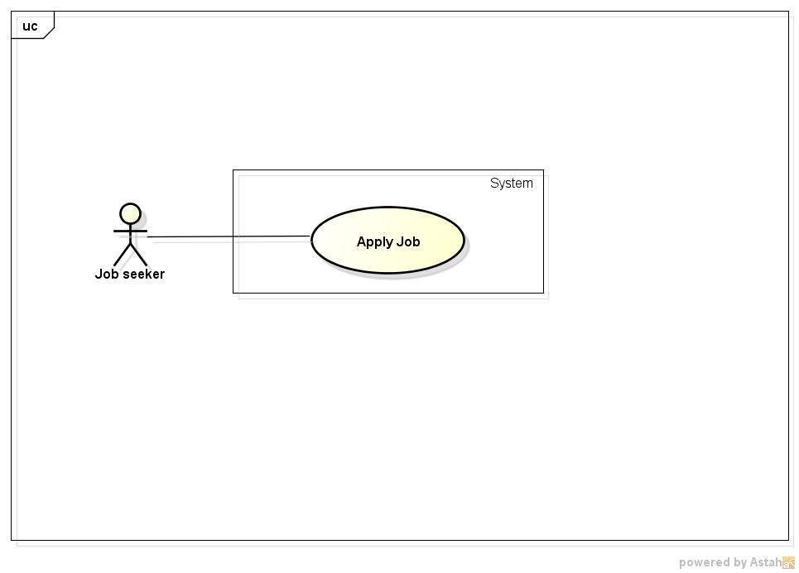

**Figure 20: <Job Seeker>Apply Job Use Case Diagram**

###### 3.2.2.2.13.2. Use case Specification

|  |  |  |  |
| --- | --- | --- | --- |
| **USE CASE –018** | | | |
| **Use Case No.** | 018 | **Use Case Version** | 1.0 |
| **Use Case Name** | Apply Job | | |
| **Author** | Nguyen Ngoc Thien | | |
| **Date** | 18/05/2015 | **Priority** | High |
| **Actor:**   * Job Seeker   **Summary:**   * This use case allow user to apply a job on Job Searching System   **Goal:**   * Allow job seeker send apply request to recruiter   **Triggers:**   * Click on a job post * In a job post click “Nộp đơn” button, “Nộp đơn” dialog is displayed * Then in “Nộp đơn” dialog click button “Gửi”   **Preconditions:**   * User login successfully with role Job Seeker * Have at least a job post on Job Searching System * Redirect successfully to a job post’s information page   **Post Conditions:**   * Apply request of job seeker is sent to recruiter   **Main Success Scenario:**   |  |  |  | | --- | --- | --- | | Step | Actor Action | System Response | | 1 | Select a job post in Job Searching System | Redirect to “Thông tin công việc” page | | 2 | Click “Nộp đơn” | Display a “Nộp đơn ”dialog contains:   * Overview information of jobseeker like: avatar, name, email, location, phone number * “Hồ sơ” radio button with options allow user choose Resumes which they created on Job Searching System or they can upload your CV file * “Thư giới thiệu” text area, maxlength:10000 * “Gửi” button * “Hủy” button | | 3 | Select “Gửi” button | - Sending apply job request to recruiter contains information in “Nộp đơn” dialog  - Dismiss “Nộp đơn” dialog   * Display send applied request success dialog |   **Alternative Scenario:**   |  |  |  | | --- | --- | --- | | No | Actor Action | System Response | | 1 | At step 3 click “Hủy” button instead of “Gửi” button | Dismiss “Nộp đơn” dialog |   **Exceptions:**  **N/A**  **Relationships:**   * Login * View job   **Business Rules:**   * A jobseeker cannot send many apply request for a job | | | |

##### 3.2.2.2.14. <Job Seeker> View Applied Job Request

###### 3.2.2.2.14.1. Use case Diagram

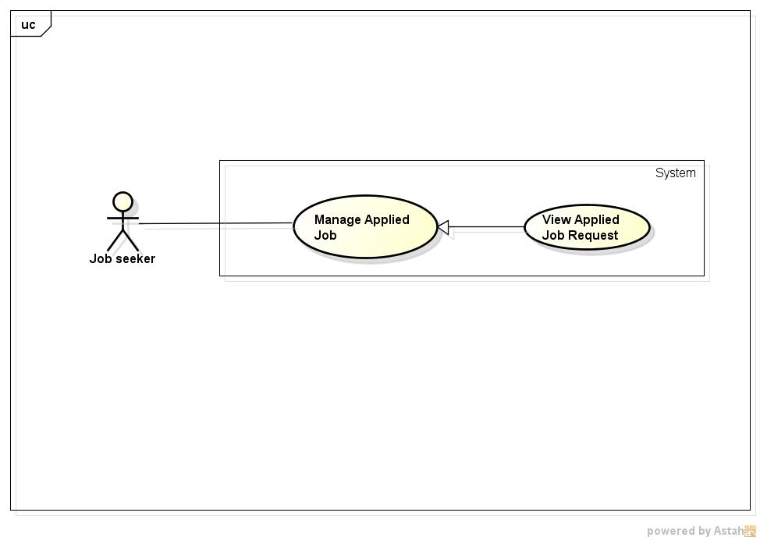

**Figure 21: <Job Seeker>View Applied Job request Use case Diagram**

###### 3.2.2.2.14.2. Use case Specification

|  |  |  |  |
| --- | --- | --- | --- |
| **USE CASE –019** | | | |
| **Use Case No.** | 019 | **Use Case Version** | 1.0 |
| **Use Case Name** | View Applied Job Request | | |
| **Author** | Nguyen Ngoc Thien | | |
| **Date** | 18/05/2015 | **Priority** | High |
| **Actor:**   * Job Seeker   **Summary:**   * This use case allow user to view applied job request   **Goal:**   * View applied job requests   **Triggers:**   * Click “Công việc cuả tôi” item in drop down menu of job seeker   **Preconditions:**   * Login successfully with role Job seeker   **Post Conditions:**   * Display a list of applied job request or “Bạn hiện tại không ứng tuyển vào bất kì công việc nào” message   **Main Success Scenario:**   |  |  |  | | --- | --- | --- | | Step | Actor Action | System Response | | 1 | Click “Công việc của tôi” item on drop down menu of job seeker | Redirect to “Công việc của tôi” page contains a list of applied job request |   **Alternative Scenario:**  **N/A**  **Exceptions:**  **N/A**  **Relationships:**   * Login   **Business Rules:**  **N/A** | | | |

##### 3.2.2.2.15. <Job Seeker> Delete Applied Job

###### 3.2.2.2.15.1. Use case Diagram

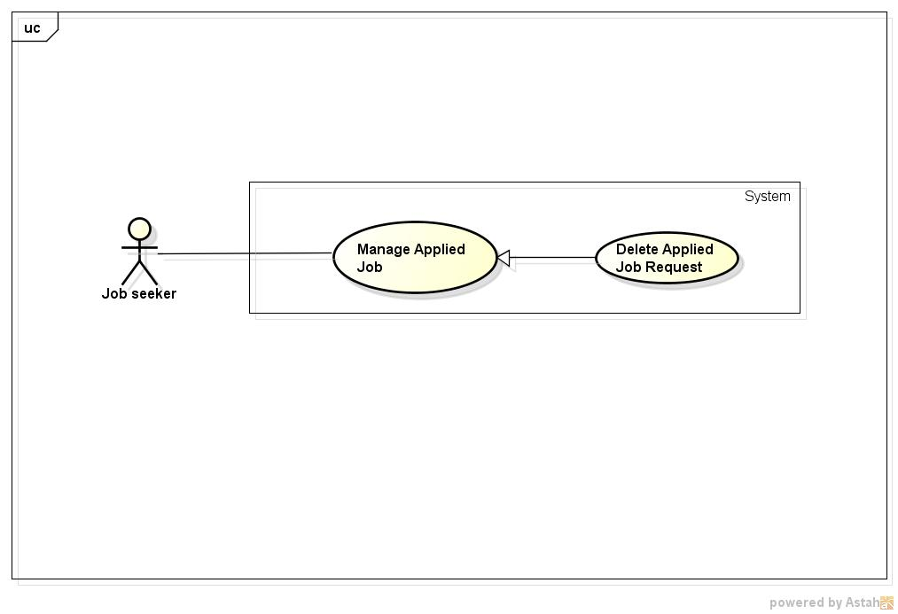

**Figure 22: <Job Seekers>Delete Applied Job Use Case Diagram**

###### 3.2.2.2.15.2. Use case Specification

|  |  |  |  |
| --- | --- | --- | --- |
| **USE CASE –020** | | | |
| **Use Case No.** | 020 | **Use Case Version** | 1.0 |
| **Use Case Name** | Delete Applied Job | | |
| **Author** | Nguyen Ngoc Thien | | |
| **Date** | 18/05/2015 | **Priority** | High |
| **Actor:**   * Job Seeker   **Summary:**   * This use case allow user to cancel a job request which is sent to recruiter   **Goal:**   * Delete a job request   **Triggers:**   * From drop down menu of jobseeker click on “Công việc của tôi” item * Click “Xóa” link on same line with job that you want to cancel apply request   **Preconditions:**   * Job seeker have at least a job request   **Post Conditions:**   * Cancel a apply request to recruiter   **Main Success Scenario:**   |  |  |  | | --- | --- | --- | | Step | Actor Action | System Response | | 1 | Click “Công việc của tôi” item on drop down menu of jobseeker | Redirect to “Công việc của tôi” page contains a list of apply job requests | | 2 | Click “Xóa” link on same line with apply job request which want to delete | Delete applied job request in database and send message to inform about canceling applied job request of job seeker to recruiter |   **Alternative Scenario:**  N/A  **Exceptions:**  N/A  **Relationships:**   * Login   **Business Rules:**  N/A | | | |

##### 3.2.2.2.16. <Job Seeker> Create entry

###### 3.2.2.2.16.1. Use case Diagram

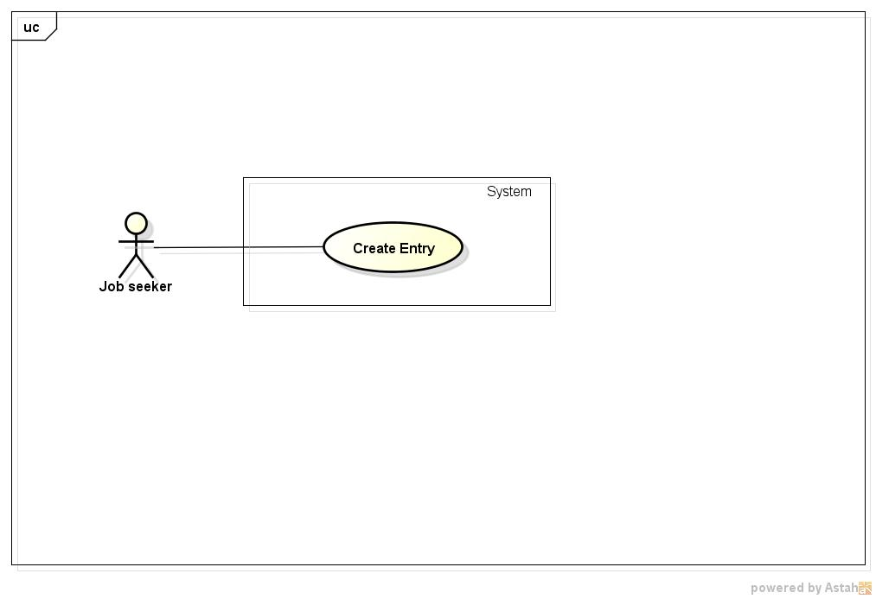

**Figure 23: <Job Seeker>Create Entry Use Case Diagram**

###### 3.2.2.2.16.2. Use case Specification

|  |  |  |  |
| --- | --- | --- | --- |
| **USE CASE –021** | | | |
| **Use Case No.** | 021 | **Use Case Version** | 1.0 |
| **Use Case Name** | Create entry | | |
| **Author** | Nguyen Ngoc Thien | | |
| **Date** | 18/05/2015 | **Priority** | High |
| **Actor:**   * Job Seeker   **Summary:**   * This use case allow user to create an entry   **Goal:**   * Create an entry   **Triggers:**   * Click “Tạo bài viết” item in drop down menu of job seeker   **Preconditions:**   * Login successfully with role Job seeker   **Post Conditions:**   * Add entry to database and display it to “Thảo luận” page   **Main Success Scenario:**   |  |  |  | | --- | --- | --- | | Step | Actor Action | System Response | | 1 | Click “Tạo bài viết” item on drop down menu of job seeker | Redirect to “Bài viết mới” page contains below items:   * “Tiêu đề” text box , required , max length 50 character * “Nội dung” text entry box , required, max length :10000 character which support html tag, image tags, paragraph formation. * “Từ khóa tìm kiếm” text box, max length:1000 * “Lưu” button * “Xem trước ” button | | 2 | Fill information then click button “Lưu” | - Add new entry to database and redirect to “Thảo luận” page |   **Alternative Scenario:**   |  |  |  | | --- | --- | --- | | No | Actor Action | System Response | | 1 | At step 3 click “Xem trước” button instead of “Lưu” button | Show preview entry in a dialog |   **Exceptions:**   |  |  |  | | --- | --- | --- | | No | Actor Action | System Response | | 1 | Leave empty on mandatory fields | Auto show error message “Vui lòng nhập thông tin cần thiết” beside mandatory fields | | 2 | Input information to “Nội dung” field with length out of valid range | Auto show error message “Nội dung không được quá 10000 ký tự”besides text box of that field | | 3 | Input information to “Từ khóa tìm kiếm” field with length out of valid range | Auto show error message “Nội dung không được quá 1000 ký tự” besides text box of that field |   **Relationships:**   * Login   **Business Rules:**  **N/A** | | | |

##### 3.2.2.2.17. <Job Seeker> View Message

###### 3.2.2.2.17.1. Use case Diagram

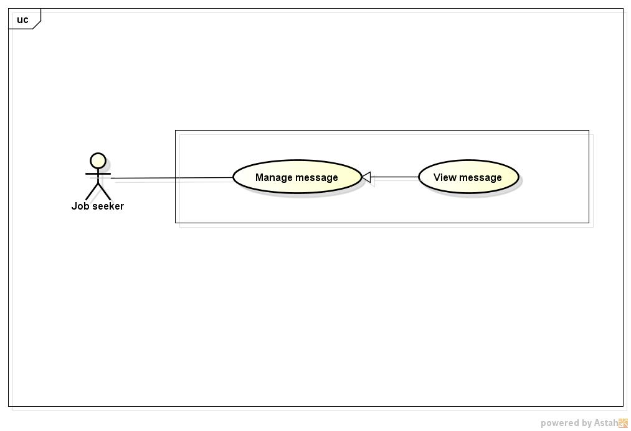

**Figure 24: <Job Seeker>View Message Use Case Diagram**

###### 3.2.2.2.17.2. Use case Specification

|  |  |  |  |
| --- | --- | --- | --- |
| **USE CASE –001** | | | |
| **Use Case No.** | 022 | **Use Case Version** | 1.0 |
| **Use Case Name** | View message | | |
| **Author** | Nguyen Ngoc Thien | | |
| **Date** | 18/05/2015 | **Priority** | High |
| **Actor:**   * Job Seeker * Recruiter * Manager * Administrator   **Summary:**   * This use case allow user see messages are sent from others   **Goal:**   * View messages   **Triggers:**   * Click “Tin nhắn” item in drop down menu of user   **Preconditions:**   * Login successfully   **Post Conditions:**   * Display a list of message or “Empty” message   **Main Success Scenario:**   |  |  |  | | --- | --- | --- | | Step | Actor Action | System Response | | 1 | Click “Tin nhắn” item on drop down menu of job seeker | Redirect to “Tin nhắn” page contains below items:   * List of message with checkbox in every item * “Tạo tin nhắn”button. * “Xóa tin nhắn” button |   **Alternative Scenario:**  N/A  **Exceptions:**  N/A  **Relationships:**   * Login   **Business Rules:**  N/A | | | |

##### 3.2.2.2.18. <Job Seeker> Create Message

###### 3.2.2.2.18.1. Use case Diagram

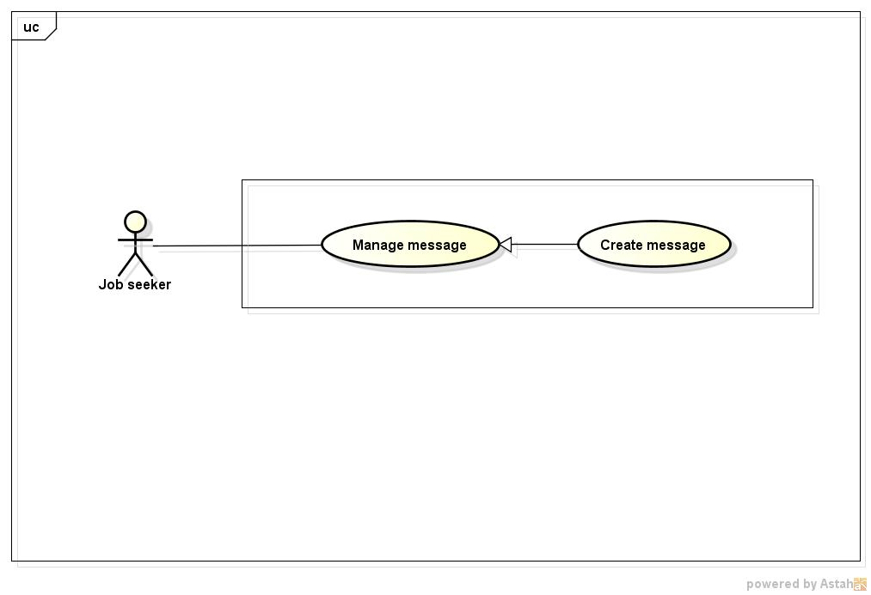

**Figure 25: <Job Seeker> Create Message Use Case Diagram**

###### 3.2.2.2.18.2. Use case Specification

|  |  |  |  |
| --- | --- | --- | --- |
| **USE CASE –023** | | | |
| **Use Case No.** | 023 | **Use Case Version** | 1.0 |
| **Use Case Name** | Create message | | |
| **Author** | Nguyen Ngoc Thien | | |
| **Date** | 18/05/2015 | **Priority** | High |
| **Actor:**   * Job Seeker * Recruiter * Manager * Administrator   **Summary:**   * This use case allow user create message and send to others   **Goal:**   * Send messages   **Triggers:**   * Click “Tin nhắn” item in drop down menu of user * Then click “Tạo tin nhắn ” button   **Preconditions:**   * Login successfully   **Post Conditions:**   * Send successfully a message to other   **Main Success Scenario:**   |  |  |  | | --- | --- | --- | | Step | Actor Action | System Response | | 1 | Click “Tin nhắn” item on drop down menu of job seeker | Redirect to “Tin nhắn” page contains below items:   * List of message with checkbox in every item * “Tạo tin nhắn”button. * “Xóa tin nhắn” button | | 2 | Click “Tạo tin nhắn” button | Display a dialog contains:   * “Người nhận” textbox, required * “Tiêu đề” textbox, required * “Nội dung” text area, required * “Đính kèm” button icon * “Gửi” button * “Hủy” button | | 3 | Input information and click “Gửi” button |  |   **Alternative Scenario:**   |  |  |  | | --- | --- | --- | | No | Actor Action | System Response | | 1 | At step 3 click “Hủy” button instead of “Gửi” button | Dismiss dialog |   **Exceptions:**   |  |  |  | | --- | --- | --- | | No | Actor Action | System Response | | 1 | Leave empty on mandatory fields | Auto show error message “Vui lòng nhập thông tin cần thiết” beside mandatory fields |   **Relationships:**   * Login   **Business Rules:**  N/A | | | |

##### 3.2.2.2.19. <Job Seeker> Delete message

###### 3.2.2.2.19.1. Use case Diagram

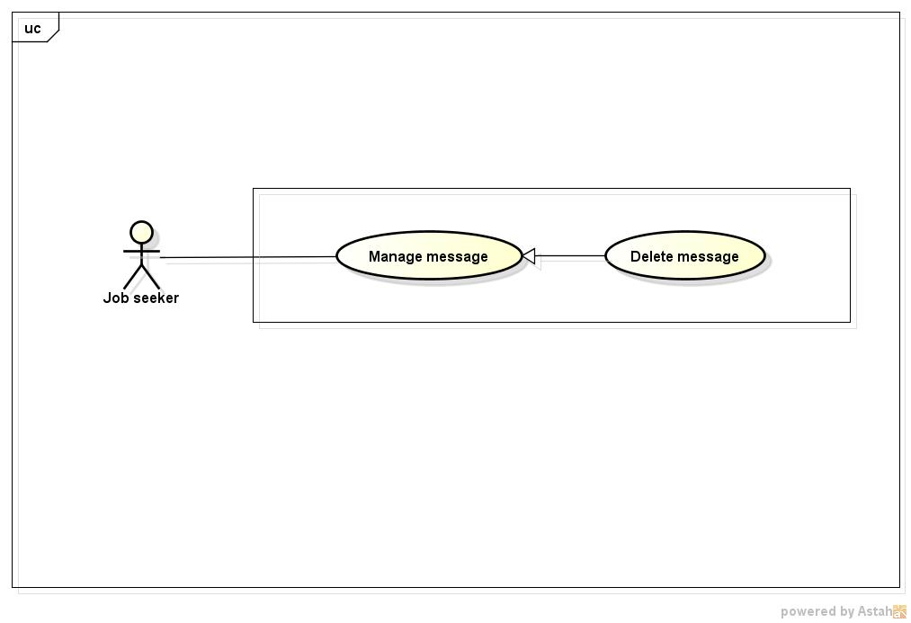

**Figure 26: <Job Seeker>Search Jobs Use Case Diagram**

###### 3.2.2.2.19.2. Use case Specification

|  |  |  |  |
| --- | --- | --- | --- |
| **USE CASE –024** | | | |
| **Use Case No.** | 024 | **Use Case Version** | 1.0 |
| **Use Case Name** | Delete message | | |
| **Author** | Nguyen Ngoc Thien | | |
| **Date** | 18/05/2015 | **Priority** | High |
| **Actor:**   * Job Seeker * Recruiter * Manager * Administrator   **Summary:**   * This use case allow user delete messages   **Goal:**   * Delete messages   **Triggers:**   * Click “Tin nhắn” item in drop down menu of user * Tick on checkbox on message which want to delete then click “Xóa tin nhắn” button   **Preconditions:**   * Login successfully   **Post Conditions:**   * Delete successfully messages   **Main Success Scenario:**   |  |  |  | | --- | --- | --- | | Step | Actor Action | System Response | | 1 | Click “Tin nhắn” item on drop down menu of job seeker | Redirect to “Tin nhắn” page contains below items:   * List of message with checkbox in every item * “Tạo tin nhắn”button. * “Xóa tin nhắn” button | | 2 | Tick on checkboxes which want to delete , then click button “Xóa tin nhắn” | Display a delete confirm dialog contains:   * “Bạn có muốn xóa những tin nhắn này?” text * “Có” button * “Không” button | | 3 | Click “Có” button | Delete those messages in database and refresh list of message |   **Alternative Scenario:**   |  |  |  | | --- | --- | --- | | No | Actor Action | System Response | | 1 | At step 3 click “Hủy” button instead of “Gửi” button | Dismiss dialog |   **Exceptions:**   |  |  |  | | --- | --- | --- | | No | Actor Action | System Response | | 1 | Leave empty on mandatory fields | Auto show error message “Vui lòng nhập thông tin cần thiết” beside mandatory fields |   **Relationships:**   * Login   **Business Rules:**  N/A | | | |

#### 3.2.2.3. <Recruiter> Overview Use Case

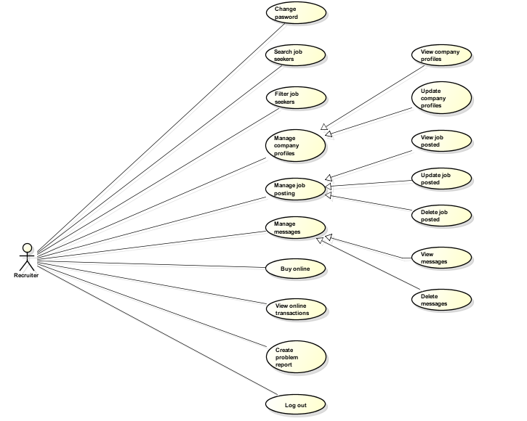

Figure 27: <Recuiters> Overview Use Case

##### 3.2.2.3.1. <Recruiter>Search Job Seekers

###### 3.2.2.3.1.1. Use case Diagram

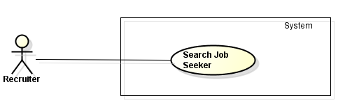

**Figure 28: <Recruiter>Search Job Seekers Use case Diagram**

###### 3.2.2.3.1.2. Use case Specification

|  |  |  |  |
| --- | --- | --- | --- |
| **USE CASE –003** | | | |
| **Use Case No.** | 025 | **Use Case Version** | 1.0 |
| **Use Case Name** | Search Job Seekers | | |
| **Author** | Tran Chung Thanh | | |
| **Date** | 18/05/2015 | **Priority** | High |
| **Actor:**  Recruiter  **Summary:**  In this case, recruiters search job seekers by fill info they want to find on Search bar  **Goal:**  Recruiter can search job seekers successfully  **Triggers:**  Fill info in search bar and click button “Tìm Kiếm” in recruiter’s home page  **Preconditions:**  Recruiter has already logged in  **Post Conditions:**  Redirect user to the recruiter’s home page  **Main Success Scenario:**   |  |  |  | | --- | --- | --- | | Step | Actor Action | System Response | | 1 | Fill info in Search bar in the recruiter’s home page |  | | 2 | Click on “Tìm Kiếm” button | Searched page will be displayed |   **Alternative Scenario:**   |  |  |  | | --- | --- | --- | | Step | Actor Action | System Response | | 1 | Fill invalid info in Search bar in the recruiter’s home page |  | | 2 | Click on “Tìm Kiếm” button | Searched page will be displayed with message “Không thể tìm được bất kỳ người tìm việc nào hợp với thông tin bạn muốn tìm ” |   **Exceptions:**   |  |  |  | | --- | --- | --- | | Step | Actor Action | System Response | | 1 | Fill nothing in Search bar in the recruiter’s home page |  | | 2 | Click on “TÌm Kiếm” button | Show notification message | | 3 | Click on “OK” button or close message | Redirect user to the recruiter’s home page |   **Relationships:**  Log in use case  **Business Rules:**   * Searched page show within 3 seconds * Must fill info to search bar to start search | | | |

##### 3.2.2.3.2. <Recruiter>Filter Job Seekers

###### 3.2.2.3.2.1. Use case Diagram

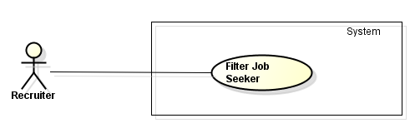

**Figure 29: <Recruiter>Filter Job Seekers Use case Diagram**

###### 3.2.2.3.2.2. Use case Specification

|  |  |  |  |
| --- | --- | --- | --- |
| **USE CASE –004** | | | |
| **Use Case No.** | 026 | **Use Case Version** | 1.0 |
| **Use Case Name** | Filter Job Seekers | | |
| **Author** | Tran Chung Thanh | | |
| **Date** | 18/05/2015 | **Priority** | High |
| **Actor:**  Recruiter  **Summary:**  In this case, recruiters can search job seekers by using filter  **Goal:**  Recruiter using filter to search job seekers successfully  **Triggers:**  Recruiter click on filter buttons named by administrator  **Preconditions:**  Recruiter has already logged in  **Post Conditions:**  Redirect user to the recruiter’s home page  **Main Success Scenario:**   |  |  |  | | --- | --- | --- | | Step | Actor Action | System Response | | 1 | Click on filter buttons on recruiter’s home page | Searched page will be displayed |   **Alternative Scenario:**  N/A  **Exceptions:**  N/A  **Relationships:**  Log in use case  **Business Rules:**   * Searched page show within 3 seconds | | | |

##### 3.2.2.3.3. <Recruiter>View Company Profile

###### 3.2.2.3.3.1. Use case Diagram

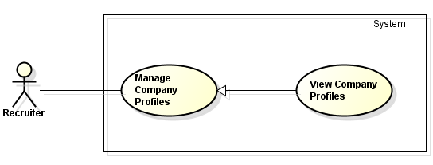

**Figure 30: <Recruiter> Manage Company Profiles Use Case Diagram**

###### 3.2.2.3.3.2. Use case Specification

|  |  |  |  |
| --- | --- | --- | --- |
| **USE CASE –027** | | | |
| **Use Case No.** | 027 | **Use Case Version** | 1.0 |
| **Use Case Name** | Manage Company Profile | | |
| **Author** | Tran Chung Thanh | | |
| **Date** | 18/05/2015 | **Priority** | High |
| **Actor:**  Recruiter  **Summary:**  In this case, recruiters can manage company profile  **Goal:**  Recruiter can view company profile successfully  **Triggers:**  Recruiter click on “Quản Lý Thông Tin Công Ty” tab in recruiters home page  **Preconditions:**  Recruiter has already logged in  **Post Conditions:**  Redirect user to the company profile page  **Main Success Scenario:**   |  |  |  | | --- | --- | --- | | Step | Actor Action | System Response | | 1 | Recruiter click on “Quản Lý Thông Tin Công Ty “ button in recruiters home page | Manage company profiles page will be displayed |   **Alternative Scenario:**  **N/A**  **Exceptions:**  N/A  **Relationships:**  Log in use case  **Business Rules:**   * Show company profile within 3 seconds | | | |
|  | | | |

##### 3.2.2.3.4. <Recruiter>Update Company Profile

###### 3.2.2.3.4.1. Use case Diagram

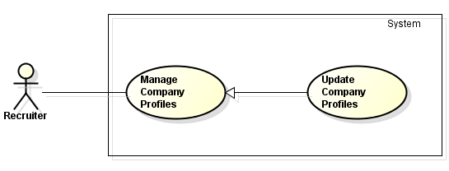

**Figure 31: <Recuiter> Manage Company Profiles Use Case Diagram**

###### 3.2.2.3.4.2. Use case Specification

|  |  |  |  |
| --- | --- | --- | --- |
| **USE CASE –028** | | | |
| **Use Case No.** | 028 | **Use Case Version** | 1.0 |
| **Use Case Name** | Update Company Profile | | |
| **Author** | Tran Chung Thanh | | |
| **Date** | 18/05/2015 | **Priority** | High |
| **Actor:**  Recruiter  **Summary:**  In this case, recruiters can manage company profile  **Goal:**  Recruiter can update company profile successfully  **Triggers:**  Recruiter click on “Quản Lý Thông Tin Công Ty” tab in recruiters home page  **Preconditions:**  Recruiter has already logged in  **Post Conditions:**  Redirect user to the company profile page  **Main Success Scenario:**   |  |  |  | | --- | --- | --- | | Step | Actor Action | System Response | | 1 | Recruiter click on “Quản Lý Thông Tin Công Ty” button in recruiters home page | Manage company profiles page will be displayed | | 2 | Recruiter click on “Cập Nhật Thông Tin Công Ty” button | Recruiter can re-fill or update new info of the company | | 3 | Recruiter fill all info of company in all text box |  | | 4 | Recruiter click on “Lưu” button | Show message : “Bạn đã cập nhật thành thông tin công ty thành công” | | 5 | Recruiter click on “OK” button or close message | Redirect recruiter to the company profile page |   **Alternative Scenario:**   |  |  |  | | --- | --- | --- | | Step | Actor Action | System Response | | 1 | Recruiter click on “Quản Lý Thông Tin Công Ty” button in recruiters home page | Manage company profiles page will be displayed | | 2 | Recruiter click on “Cập Nhật Thông Tin Công Ty” button | Recruiter can re-fill or update new info of the company | | 3 | Recruiter fill all info of company in all text box |  | | 4 | Recruiter click on “Hủy” button | Redirect recruiter to the company profile page |   **Exceptions:**   |  |  |  | | --- | --- | --- | | Step | Actor Action | System Response | | 1 | Recruiter click on “Quản Lý Thông Tin Công Ty” button in recruiters home page | Manage company profiles page will be displayed | | 2 | Recruiter click on “Cập Nhật Thông Tin Công Ty” button | Recruiter can re-fill or update new info of the company | | 3 | Recruiter fill some info of company , but skipped some mandatory info |  | | 4 | Recruiter click on “Lưu” button | Show all required messages for all missing mandatory info | | 5 | Recruiter click on “OK” button or close message | Redirect recruiter to the company’ profiles page |   **Relationships:**  Log in use case  **Business Rules:**   * Some mandatory data fields must required * Update profile within 3 seconds | | | |

##### 3.2.2.3.5. <Recruiter>View Job Posting

###### 3.2.2.3.5.1. Use case Diagram

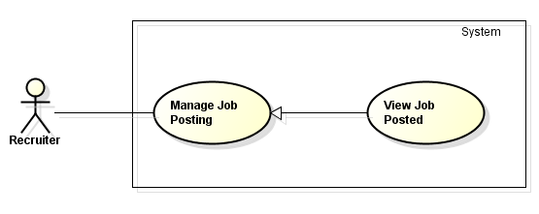

**Figure 32: <Recuiter> Manage Company Profiles Use Case Diagram**

###### 3.2.2.3.5.2. Use case Specification

|  |  |  |  |
| --- | --- | --- | --- |
| **USE CASE –029** | | | |
| **Use Case No.** | 029 | **Use Case Version** | 1.0 |
| **Use Case Name** | View Job Posting | | |
| **Author** | Tran Chung Thanh | | |
| **Date** | 18/05/2015 | **Priority** | High |
| **Actor:**  Recruiter  **Summary:**  In this case, recruiters can manage job posting  **Goal:**  Recruiter can view job posting successfully  **Triggers:**  Recruiter click on “Quản Lý Công Việc” tab in recruiters home page, then click on “Xem” button in manage job page  **Preconditions:**  Recruiter has already logged in  **Post Conditions:**  N/A  **Main Success Scenario:**   |  |  |  | | --- | --- | --- | | Step | Actor Action | System Response | | 1 | Recruiter click on “Quản Lý Công Việc” button in recruiters home page | Manage job page will be displayed | | 2 | Recruiter click on “Xem” button beside any job posted. | Jobs info page will be displayed |   **Alternative Scenario:**  **N/A**  **Exceptions:**  N/A  **Relationships:**  Log in use case  **Business Rules:**   * Show job’s info within 3 seconds * Recruiter have to create a job before view the job | | | |
|  | | | |

##### 3.2.2.3.6. <Recruiter>Update Job Posting

###### 3.2.2.3.6.1. Use case Diagram

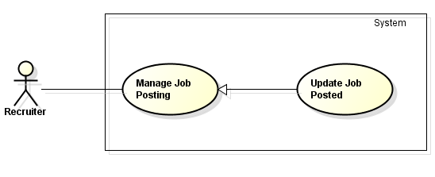

**Figure 33: <Recuiter> Manage Company Profiles Use Case Diagram**

###### 3.2.2.3.6.2. Use case Specification

|  |  |  |  |
| --- | --- | --- | --- |
| **USE CASE –030** | | | |
| **Use Case No.** | 030 | **Use Case Version** | 1.0 |
| **Use Case Name** | Update Job Posting | | |
| **Author** | Tran Chung Thanh | | |
| **Date** | 18/05/2015 | **Priority** | High |
| **Actor:**  Recruiter  **Summary:**  In this case, recruiters can manage job posting  **Goal:**  Recruiter can view job posting successfully  **Triggers:**  Recruiter click on “Quản Lý Công Việc” tab in recruiters home page, then click on “Cập Nhật” button beside any job posted in manage job page  **Preconditions:**  Recruiter has already logged in  **Post Conditions:**  Redirect user to the job’s info page  **Main Success Scenario:**   |  |  |  | | --- | --- | --- | | Step | Actor Action | System Response | | 1 | Recruiter click on “Quản Lý Công Việc” button in recruiters home page | Manage job page will be displayed | | 2 | Recruiter choice click on “Cập Nhật ” button beside any job posted | Recruiter can refill or update info of the job | | Recruiter fill all info of the job |  | | Recruiter click on “Lưu” button | Show message : “Bạn Đã Cập Nhật Thông Tin Công Việc Thành Công” | | Recruiter click on “OK” button | Redirect recruiter to the Job’s info page |   **Alternative Scenario:**   |  |  |  | | --- | --- | --- | | Step | Actor Action | System Response | | 1 | Recruiter click on “Quản Lý Công Việc” button in recruiters home page | Manage job page will be displayed | | 3 | Recruiter choice click on “Cập Nhật” button beside any job posted | Recruiter can refill or update info of the job | | Recruiter refill all info of the job |  | | Recruiter click on “Hủy” button | Redirect recruiter to the Job’s info page |   **Exceptions:**   |  |  |  | | --- | --- | --- | | Step | Actor Action | System Response | | 1 | Recruiter click on “Quản Lý Công Việc” button in recruiters home page | Manage job page will be displayed | | 2 | Recruiter choice click on “Cập Nhật” button beside any job posted | Recruiter can refill or update info of the job | | Recruiter fill some info of the job, but skipped some mandatory info |  | | Recruiter click on “Lưu” button | Show all required message for all missing mandatory info | | Recruiter click on “OK” button or close messages | Redirect recruiter to the Job’s info page |   **Relationships:**  Log in use case  **Business Rules:**   * Some mandatory data fields must required * Update the job within 3 seconds * Recruiter have to create a job before update the job | | | |

##### 3.2.2.3.7. <Recruiter>Delete Job Posting

###### 3.2.2.3.7.1. Use case Diagram

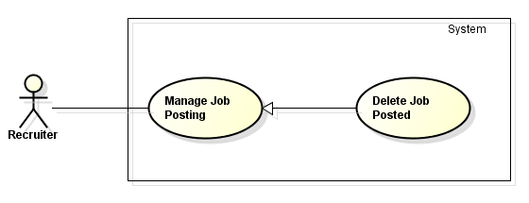

**Figure 34: <Recuiter> Manage Company Profiles Use Case Diagram**

###### 3.2.2.3.7.2. Use case Specification

|  |  |  |  |
| --- | --- | --- | --- |
| **USE CASE –031** | | | |
| **Use Case No.** | 031 | **Use Case Version** | 1.0 |
| **Use Case Name** | Delete Job Posting | | |
| **Author** | Tran Chung Thanh | | |
| **Date** | 18/05/2015 | **Priority** | High |
| **Actor:**  Recruiter  **Summary:**  In this case, recruiters can manage job posting  **Goal:**  Recruiter can view job posting successfully  **Triggers:**  Recruiter click on “Quản Lý Công Việc” tab in recruiters home page, then click on “Xóa” button beside any job posted  **Preconditions:**  Recruiter has already logged in  **Post Conditions:**  Redirect user to the job’s info page  **Main Success Scenario:**   |  |  |  | | --- | --- | --- | | Step | Actor Action | System Response | | 1 | Recruiter click on “Quản Lý Công Việc” button in recruiters home page | Manage job page will be displayed | | 2 | Recruiter click on “Xóa” button beside any job posted. | Show notification message | | Recruiter click on “OK” button | Redirect recruiter to the manage job page |   **Alternative Scenario:**   |  |  |  | | --- | --- | --- | | Step | Actor Action | System Response | | 1 | Recruiter click on “Quản Lý Công Việc”” button in recruiters home page | Manage job page will be displayed | | 2 | Recruiter click on “Xóa” button beside any job posted. | Show notification message | | Recruiter click on “Hủy” button or close message | Redirect recruiter to the manage job page |   **Exceptions:**  **Relationships:**  Log in use case  **Business Rules:**   * Delete job within 3 seconds * Recruiter have to create a job before delete the job | | | |

##### 3.2.2.3.8. <Recruiter>Buy Online

###### 3.2.2.3.8.1. Use case Diagram

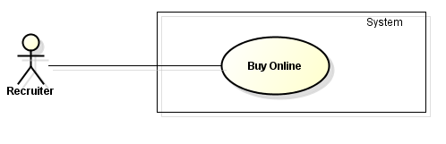

**Figure 35: <Recuiter> Buy Online Use Case Diagram**

###### 3.2.2.3.8.2. Use case Specification

|  |  |  |  |
| --- | --- | --- | --- |
| **USE CASE –014** | | | |
| **Use Case No.** | 032 | **Use Case Version** | 1.0 |
| **Use Case Name** | Buy Online | | |
| **Author** | Tran Chung Thanh | | |
| **Date** | 18/05/2015 | **Priority** | High |
| **Actor:**  Recruiter  **Summary:**  In this case, recruiters can buy service packs  **Goal:**  Recruiter can buy service packs successfully  **Triggers:**  Recruiter click on “Mua Dịch Vụ” tab in recruiters home page  **Preconditions:**  Recruiter has already logged in  **Post Conditions:**  Redirect user to the service packs page  **Main Success Scenario:**   |  |  |  | | --- | --- | --- | | Step | Actor Action | System Response | | 1 | Recruiter click on “Mua Dịch Vụ” tab in recruiters home page | Service packs page will be displayed | | 2 | Recruiter click button “Mua” below any service packs | Show notification message | | Recruiter click on “OK” button | Redirect user to the service packs page |   **Alternative Scenario:**   |  |  |  | | --- | --- | --- | | Step | Actor Action | System Response | | 1 | Recruiter click on “Mua Dịch Vụ” tab in recruiters home page | Service packs page will be displayed | | 2 | Recruiter click button “Mua” below any service packs | Show notification message | | Recruiter click on “Hủy” button or close message | Redirect user to the service packs page |   **Exceptions:**   |  |  |  | | --- | --- | --- | | Step | Actor Action | System Response | | 1 | Recruiter click on “Mua Dịch Vụ” tab in recruiters home page | Service packs page will be displayed | | 2 | Recruiter click button “Mua” below any service packs, but the money doesn’t enough to buy the service | Show notification message | | Recruiter click on “OK” button or close message | Redirect user to the service packs page |   **Relationships:**  Log in use case  **Business Rules:**   * After bought service packs active immediately * Money in account must more than the price of service pack * Buy proceed within 3 seconds | | | |

##### 3.2.2.3.9. <Recruiter>View Online Transaction

###### 3.2.2.3.9.1. Use case Diagram

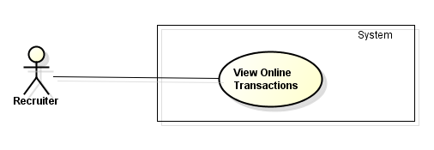

**Figure 36: <Recuiter> View Online Transaction Use Case Diagram**

###### 3.2.2.3.9.2. Use case Specification

|  |  |  |  |
| --- | --- | --- | --- |
| **USE CASE –033** | | | |
| **Use Case No.** | 033 | **Use Case Version** | 1.0 |
| **Use Case Name** | View Online Transactions | | |
| **Author** | Tran Chung Thanh | | |
| **Date** | 18/05/2015 | **Priority** | High |
| **Actor:**  Recruiter  **Summary:**  In this case, recruiters can view all online transactions  **Goal:**  Recruiter can view online transactions successfully  **Triggers:**  Recruiter click on “Xem Thông tin các giao dịch” tab in recruiters home page  **Preconditions:**  Recruiter has already logged in  **Post Conditions:**  N/A  **Main Success Scenario:**   |  |  |  | | --- | --- | --- | | Step | Actor Action | System Response | | 1 | Recruiter click on “Xem Thông tin các giao dịch” tab in recruiters home page | Online transactions page will be displayed |   **Alternative Scenario:**  N/A  **Exceptions:**  N/A  **Relationships:**  Log in use case  **Business Rules:**   * Online transactions show immediately | | | |

##### 3.2.2.3.10. <Recruiter>Create Problem Reports

###### 3.2.2.3.10.1. Use case Diagram

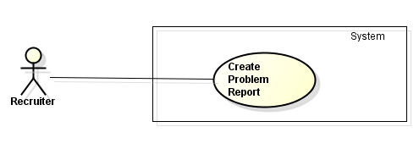

**Figure 37: <Recuiter>Create Problem Reports Use Case Diagram**

###### 3.2.2.3.10.2. Use case Specification

|  |  |  |  |
| --- | --- | --- | --- |
| **USE CASE –034** | | | |
| **Use Case No.** | 034 | **Use Case Version** | 1.0 |
| **Use Case Name** | Create Problem Report | | |
| **Author** | Tran Chung Thanh | | |
| **Date** | 18/05/2015 | **Priority** | High |
| **Actor:**  Recruiter  **Summary:**  In this case, recruiters can create problem reports to send to admin  **Goal:**  Recruiter can create problem reports successfully  **Triggers:**  Recruiter click on “Tạo Báo Cáo” tab in recruiters home page  **Preconditions:**  Recruiter has already logged in  **Post Conditions:**  Redirect recruiter to the problem report page  **Main Success Scenario:**   |  |  |  | | --- | --- | --- | | Step | Actor Action | System Response | | 1 | Recruiter click on “Tạo Báo Cáo” tab in recruiters home page | Problem reports page will be displayed | | 2 | Recruiter write report |  | | 3 | Recruiter click on “Gửi” button | Show notification message | | 4 | Recruiter click on “OK ” button or close message | Redirect recruiter to the problem report page |   **Alternative Scenario:**   |  |  |  | | --- | --- | --- | | Step | Actor Action | System Response | | 1 | Recruiter click on “Tạo Báo Cáo” tab in recruiters home page | Problem reports page will be displayed | | 2 | Recruiter write report |  | | 3 | Recruiter click on “Hủy” button | Redirect recruiter to the problem report page |   **Exceptions:**   |  |  |  | | --- | --- | --- | | Step | Actor Action | System Response | | 1 | Recruiter click on “Tạo Báo Cáo” tab in recruiters home page | Problem reports page will be displayed | | 2 | Recruiter skipped some mandatory data fields |  | | 3 | Recruiter click on “Gửi” button | Show all required messages for all missing mandatory info | | 4 | Recruiter click on “OK” or close message | Redirect recruiter to the problem report page |   **Relationships:**  Log in use case  **Business Rules:**   * Some mandatory data fields must required * Report send within 3 seconds | | | |

#### 3.2.2.4. <Administrator> Overview Use Case

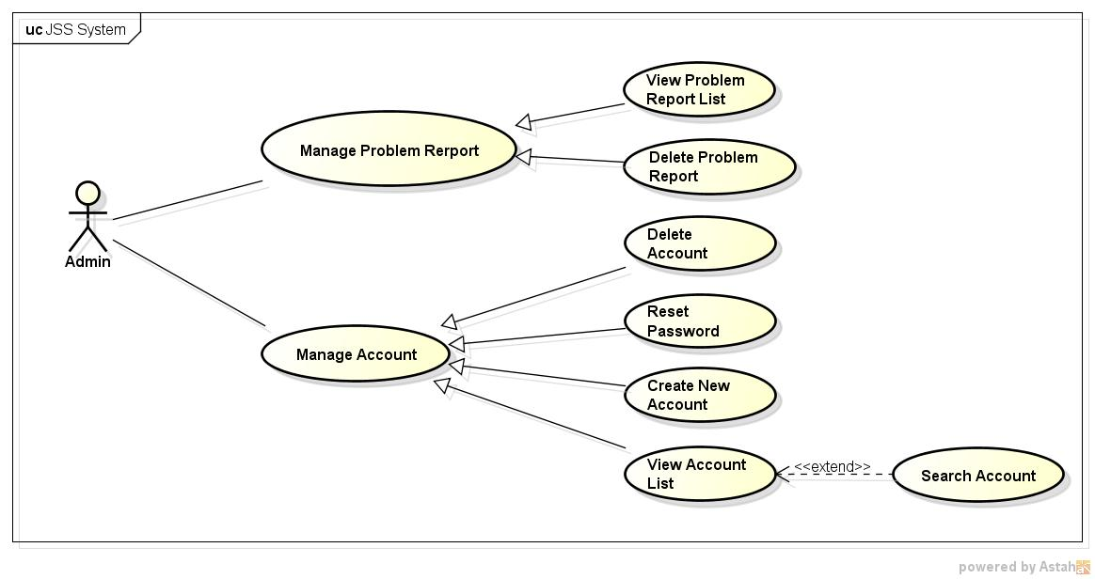

Figure 38: <Administrator> Overview Use Case

##### 3.2.2.4.1. < Administrator> View Account List and Search Account

###### 3.2.2.4.1.1. Use case Diagram

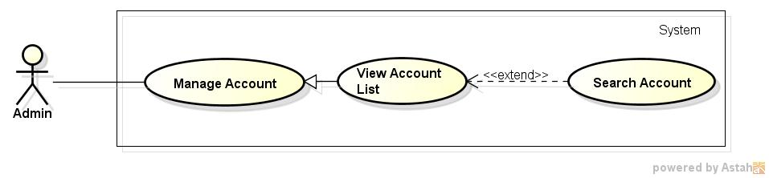

**Figure 39: <Administrator> View Account List and Search Account Use case Diagram**

###### 3.2.2.4.1.2. Use case Specification

|  |  |  |  |
| --- | --- | --- | --- |
| **USE CASE –035** | | | |
| **Use Case No.** | 035 | **Use Case Version** | 1.0 |
| **Use Case Name** | View Account List and Search Account | | |
| **Author** | Pham Quoc Thai | | |
| **Date** | 20/05/2015 | **Priority** | High |
| **Actor:**   * Administrator.   **Summary:**  In this case, admin can view account list and search account.  **Goal:**  All account display successfully.  **Triggers:**  Click on tab "Danh sách tài khoản" on Admin Home Page.  **Preconditions:**  Admin must login into website.  **Post Conditions:**  N/A  **Main Success Scenario:**   |  |  |  | | --- | --- | --- | | Step | Actor Action | System Response | | 1 | Click on tab " Danh sách tài khoản " on Admin home page. | All accounts display successfully. | | 2 | Input to Search textbox | System will show all accounts into list which their information contains the input keyword. |   **Alternative Scenario:**  N/A  **Exceptions:**  N/A  **Relationships:**  N/A  **Business Rules:**  N/A | | | |

##### 3.2.2.4.2. < Administrator > Create New Account List

###### 3.2.2.4.2.1. Use case Diagram

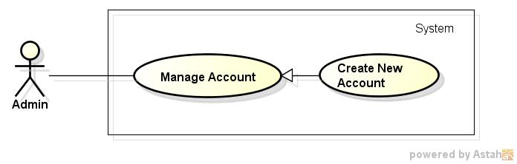

**Figure 40: <Administrator> Create New Account Use case Diagram**

###### 3.2.2.4.2.2. Use case Specification

|  |  |  |  |
| --- | --- | --- | --- |
| **USE CASE –036** | | | |
| **Use Case No.** | 036 | **Use Case Version** | 1.0 |
| **Use Case Name** | Create New Account | | |
| **Author** | Pham Quoc Thai | | |
| **Date** | 20/05/2015 | **Priority** | High |
| **Actor:**   * Administrator.   **Summary:**  In this case, admin can create new account.  **Goal:**  New account can be created.  **Triggers:**  Click button "Tạo mới tài khoản " on Account List page.  **Preconditions:**  Admin must login into website.  **Post Conditions:**  N/A  **Main Success Scenario:**   |  |  |  | | --- | --- | --- | | Step | Actor Action | System Response | | 1 | Click button "Tạo mới tài khoản " on Account List page. | Show Create New Account Page. | | 2 | Enter “Tên Tài Khoản”, “Thư Mail”, and “Mật Khẩu”, choose type account after that click Button “Tạo Mới”. | New account added into database. |   **Alternative Scenario:**  N/A  **Exceptions:**   |  |  |  | | --- | --- | --- | | No | Actor Action | System Response | | 1 |  |  |   **Relationships:**  N/A  **Business Rules:**  N/A | | | |

##### 3.2.2.4.3. < Administrator> Reset Password

###### 3.2.2.4.3.1. Use case Diagram

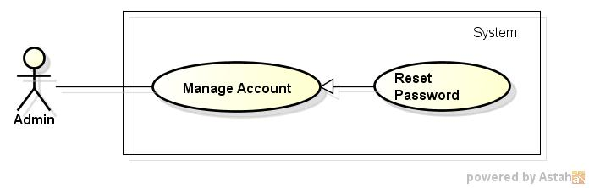

**Figure 41: <Administrator> Reset Password Use case Diagram**

###### 3.2.2.4.3.2. Use case Specification

|  |  |  |  |
| --- | --- | --- | --- |
| **USE CASE –037** | | | |
| **Use Case No.** | 037 | **Use Case Version** | 1.0 |
| **Use Case Name** | Reset Password | | |
| **Author** | Pham Quoc Thai | | |
| **Date** | 20/05/2015 | **Priority** | High |
| **Actor:**   * Administrator.   **Summary:**  In this case, administrator can reset password of specific account.  **Goal:**  Reset password of account to default password successfully.  **Triggers:**  Click on “Thiết lập lại mật khẩu” link of specific account on Account List page.  **Preconditions:**  Admin must login into website.  **Post Conditions:**  N/A  **Main Success Scenario:**   |  |  |  | | --- | --- | --- | | Step | Actor Action | System Response | | 1 | Click on “Thiết lập lại mật khẩu” link of specific account on Account List page. | Show pop up confirm. | | 2 | Click button "Xác Nhận" | Reset password of account to default password. | | Click button "Hủy" | Close pop up and return all account page. |   **Alternative Scenario:**  N/A  **Exceptions:**  N/A  **Relationships:**  N/A  **Business Rules:**  N/A | | | |

##### 3.2.2.4.4. < Administrator> Delete Account

###### 3.2.2.4.4.1. Use case Diagram

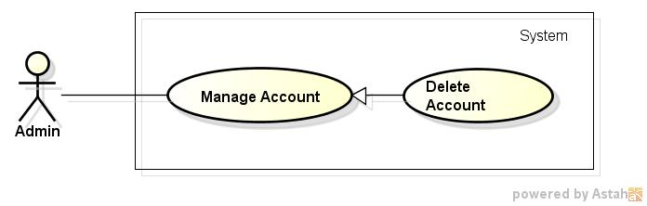

**Figure 42: <Administrator> Delete Account Use case Diagram**

###### 3.2.2.4.4.2. Use case Specification

|  |  |  |  |
| --- | --- | --- | --- |
| **USE CASE –037** | | | |
| **Use Case No.** | 037 | **Use Case Version** | 1.0 |
| **Use Case Name** | Delete account | | |
| **Author** | Pham Quoc Thai | | |
| **Date** | 20/05/2015 | **Priority** | High |
| **Actor:**   * Administrator.   **Summary:**  In this case, administrator can delete of specific account.  **Goal:**  Account can be deleted successfully.  **Triggers:**  Click on “Xóa tài khoản” link of specific account on Account List page.  **Preconditions:**  Admin must login into website.  **Post Conditions:**  N/A  **Main Success Scenario:**   |  |  |  | | --- | --- | --- | | Step | Actor Action | System Response | | 1 | Click on “Xóa tài khoản” link of specific account on Account List page. | Show pop up confirm. | | 2 | Click button "Xác Nhận" | Account has been deleted. | | Click button "Hủy" | Close pop up and return Account List page. |   **Alternative Scenario:**  N/A  **Exceptions:**  N/A  **Relationships:**  N/A  **Business Rules:**  N/A | | | |

##### 3.2.2.4.5. < Administrator> View Problem Report

###### 3.2.2.4.5.1. Use case Diagram

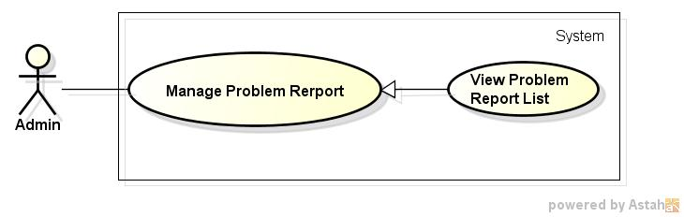

**Figure 43: <Administrator> View Problem Report Use case Diagram**

###### 3.2.2.4.5.2. Use case Specification

|  |  |  |  |
| --- | --- | --- | --- |
| **USE CASE –038** | | | |
| **Use Case No.** | 038 | **Use Case Version** | 1.0 |
| **Use Case Name** | View Problem Report List | | |
| **Author** | Pham Quoc Thai | | |
| **Date** | 20/05/2015 | **Priority** | High |
| **Actor:**   * Administrator.   **Summary:**  In this case, admin can view problem report list.  **Goal:**  All problem reports display successfully.  **Triggers:**  Click on tab "Danh sách báo cáo lỗi" on Admin Home page.  **Preconditions:**  Admin must login into website.  **Post Conditions:**  N/A  **Main Success Scenario:**   |  |  |  | | --- | --- | --- | | Step | Actor Action | System Response | | 1 | Click on tab "Danh sách báo cáo lỗi" on Admin Home page. | All problem report s display successfully. |   **Alternative Scenario:**  N/A  **Exceptions:**  N/A  **Relationships:**  N/A  **Business Rules:**  N/A | | | |

##### 3.2.2.4.6. < Administrator> Delete Problem Report

###### 3.2.2.4.6.1. Use case Diagram

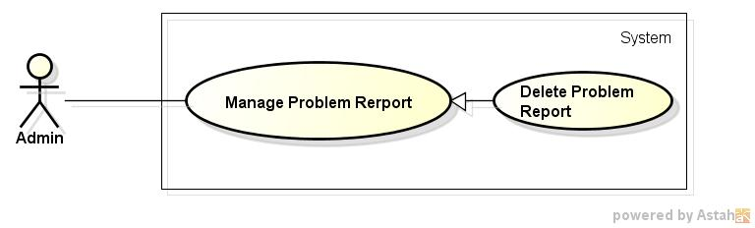

**Figure 44: <Administrator> Delete Problem Report Use case Diagram**

###### 3.2.2.4.6.2. Use case Specification

|  |  |  |  |
| --- | --- | --- | --- |
| **USE CASE –006** | | | |
| **Use Case No.** | 039 | **Use Case Version** | 1.0 |
| **Use Case Name** | Delete Problem Report | | |
| **Author** | Pham Quoc Thai | | |
| **Date** | 20/05/2015 | **Priority** | High |
| **Actor:**   * Administrator.   **Summary:**  In this case, administrator can delete of specific problem report.  **Goal:**  Problem report can be deleted successfully.  **Triggers:**  Click on “Xóa” link of specific problem report on Problem Report List page.  **Preconditions:**  Admin must login into website.  **Post Conditions:**  N/A  **Main Success Scenario:**   |  |  |  | | --- | --- | --- | | Step | Actor Action | System Response | | 1 | Click on “Xóa” link of specific problem report on Problem Report List page. | Show pop up confirm. | | 2 | Click button "Xác Nhận" | Problem report has been deleted. | | Click button "Hủy" | Close pop up and return Problem Report List page. |   **Alternative Scenario:**  N/A  **Exceptions:**  N/A  **Relationships:**  N/A  **Business Rules:**  N/A | | | |

***3.2.2.5. <Manager> Overview Use Case***

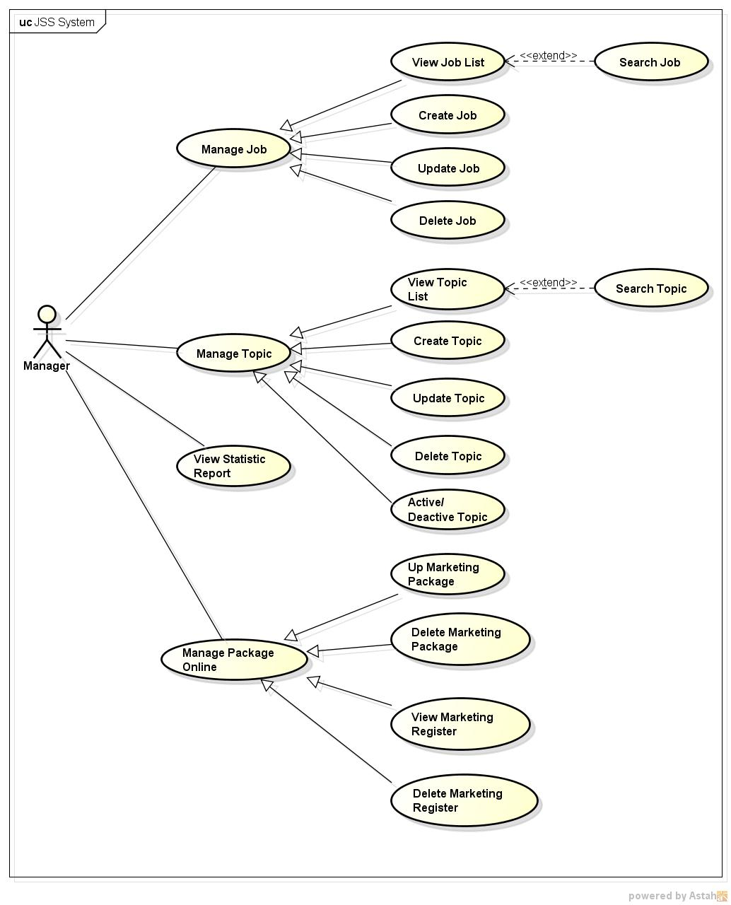

**Figure 45: <Manager> Overview Use Case**

3.2.2.5.1. < Manager> View Job List and Search Job

*3.2.2.5.1.1. Use case Diagram*

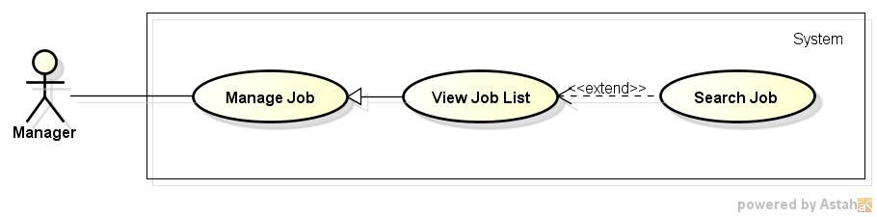

**Figure 46: <Manager> View Job List and Search Job Use case Diagram**

*3.2.2.5.1.2. Use case Specification*

|  |  |  |  |
| --- | --- | --- | --- |
| **USE CASE –040** | | | |
| **Use Case No.** | 040 | **Use Case Version** | 1.0 |
| **Use Case Name** | View Job List and Search job | | |
| **Author** | Pham Quoc Thai | | |
| **Date** | 20/05/2015 | **Priority** | High |
| **Actor:**   * Manager.   **Summary:**  In this case, manager can view job list.  **Goal:**  All job display successfully.  **Triggers:**  Click on tab "Danh sách việc làm" on Manager Home page.  **Preconditions:**  Manager must login into website.  **Post Conditions:**  N/A  **Main Success Scenario:**   |  |  |  | | --- | --- | --- | | Step | Actor Action | System Response | | 1 | Click on tab "Danh sách việc làm" on Manager Home page. | All job display successfully. | | 2 | Input to Search textbox | System will show all job into list which their information contains the input keyword. |   **Alternative Scenario:**  N/A  **Exceptions:**  N/A  **Relationships:**  N/A  **Business Rules:**  N/A | | | |

3.2.2.5.2. < Manager> Create new job

*3.2.2.5.2.1. Use case Diagram*

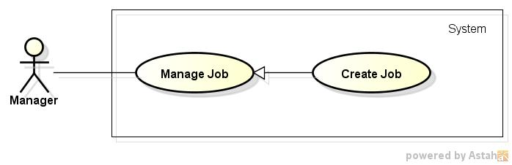

**Figure 47: <Manager> Create new job Use case Diagram**

*3.2.2.5.2.2. Use case Specification*

|  |  |  |  |
| --- | --- | --- | --- |
| **USE CASE –041** | | | |
| **Use Case No.** | 041 | **Use Case Version** | 1.0 |
| **Use Case Name** | Create new job | | |
| **Author** | Pham Quoc Thai | | |
| **Date** | 20/05/2015 | **Priority** | High |
| **Actor:**   * Manager.   **Summary:**  In this case, manager can create new job.  **Goal:**  New job be created.  **Triggers:**  Click button "Tạo việc làm mới " on Manager home page.  **Preconditions:**  Manager must login into website.  **Post Conditions:**  N/A  **Main Success Scenario:**   |  |  |  | | --- | --- | --- | | Step | Actor Action | System Response | | 1 | Click button "Tạo việc làm mới " on Manager home page. | Show Create New Job page. | | 2 | Enter “Tên việc làm”, “Nhóm việc làm" after that click Button “Tạo mới”. | New job added into database. |   **Alternative Scenario:**  N/A  **Exceptions:**   |  |  |  | | --- | --- | --- | | No | Actor Action | System Response | | 1 |  |  |   **Relationships:**  N/A  **Business Rules:**  N/A | | | |

3.2.2.5.3. < Manager> Update job

*3.2.2.5.3.1. Use case Diagram*

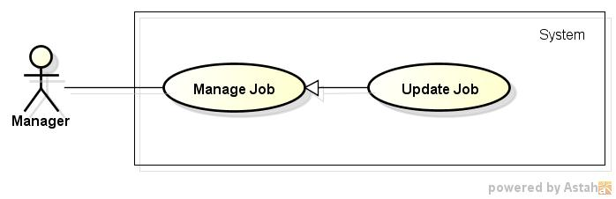

**Figure 48: <Manager> Update job Use case Diagram**

*3.2.2.5.3.2. Use case Specification*

|  |  |  |  |
| --- | --- | --- | --- |
| **USE CASE –042** | | | |
| **Use Case No.** | 042 | **Use Case Version** | 1.0 |
| **Use Case Name** | Updatejob | | |
| **Author** | Pham Quoc Thai | | |
| **Date** | 20/05/2015 | **Priority** | High |
| **Actor:**   * Manager.   **Summary:**  In this case, manager can update infomation of specific job.  **Goal:**  Update job information successfully.  **Triggers:**  Click on “Cập nhật” link of specific job on Job List page.  **Preconditions:**  Manager must login into website.  **Post Conditions:**  N/A  **Main Success Scenario:**   |  |  |  | | --- | --- | --- | | Step | Actor Action | System Response | | 1 | After input information to need update, click on “Cậpnhật” link of specific job on All job page. | Show pop up confirm. | | 2 | Click button "Xác Nhận" | Update job information successfully. | | Click button "Hủy" | Close pop up and return Job List page. |   **Alternative Scenario:**  N/A  **Exceptions:**  N/A  **Relationships:**  N/A  **Business Rules:**  N/A | | | |

3.2.2.5.4. < Manager>Deletejob

*3.2.2.5.4.1. Use case Diagram*

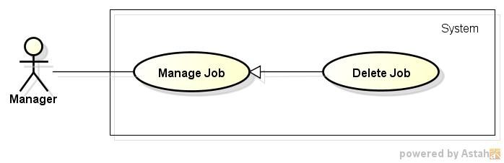

**Figure 49: <Manager>Deletejob Use case Diagram**

*3.2.2.5.4.2. Use case Specification*

|  |  |  |  |
| --- | --- | --- | --- |
| **USE CASE –043** | | | |
| **Use Case No.** | 043 | **Use Case Version** | 1.0 |
| **Use Case Name** | Delete job | | |
| **Author** | Pham Quoc Thai | | |
| **Date** | 20/05/2015 | **Priority** | High |
| **Actor:**   * Manager.   **Summary:**  In this case, manager can delete of specific job.  **Goal:**  Job be deleted successfully.  **Triggers:**  Click on “Xóa” link of specific job on Job List page.  **Preconditions:**  Manager must login into website.  **Post Conditions:**  N/A  **Main Success Scenario:**   |  |  |  | | --- | --- | --- | | Step | Actor Action | System Response | | 1 | Click on “Xóa” link of specific account on Job List page. | Show pop up confirm. | | 2 | Click button "Xác Nhận" | Job has been deleted. | | Click button "Hủy" | Close pop up and return Job List page. |   **Alternative Scenario:**  N/A  **Exceptions:**  N/A  **Relationships:**  N/A  **Business Rules:**  N/A | | | |

3.2.2.5.5. < Manager>View topic

*3.2.2.5.5.1. Use case Diagram*

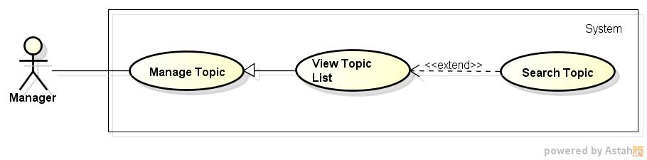

**Figure 50: <Manager>View topicUse case Diagram**

*3.2.2.5.5.2. Use case Specification*

|  |  |  |  |
| --- | --- | --- | --- |
| **USE CASE –044** | | | |
| **Use Case No.** | 044 | **Use Case Version** | 1.0 |
| **Use Case Name** | View topic | | |
| **Author** | Pham Quoc Thai | | |
| **Date** | 20/05/2015 | **Priority** | High |
| **Actor:**   * Manager.   **Summary:**  In this case, manager can view topic list.  **Goal:**  All topic display successfully.  **Triggers:**  Click on tab "Danh sách chủ đề" on manager home page.  **Preconditions:**  Manager must login into website.  **Post Conditions:**  N/A  **Main Success Scenario:**   |  |  |  | | --- | --- | --- | | Step | Actor Action | System Response | | 1 | Click on tab "Danh sách chủ đề" on manager home page. | All topic display successfully. |   **Alternative Scenario:**  N/A  **Exceptions:**  N/A  **Relationships:**  N/A  **Business Rules:**  N/A | | | |

3.2.2.5.6. < Manager>Create topic

*3.2.2.5.6.1. Use case Diagram*

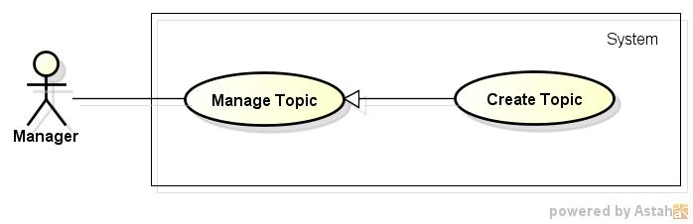

**Figure 51: <Manager>Create topicUse case Diagram**

*3.2.2.5.6.2. Use case Specification*

|  |  |  |  |
| --- | --- | --- | --- |
| **USE CASE –045** | | | |
| **Use Case No.** | 045 | **Use Case Version** | 1.0 |
| **Use Case Name** | Create topic | | |
| **Author** | Pham Quoc Thai | | |
| **Date** | 20/05/2015 | **Priority** | High |
| **Actor:**   * Manager.   **Summary:**  In this case, after logging, manager can create new topic.  **Goal:**  New topic be created.  **Triggers:**  Click button "Tạo chủ đề mới " on Topic List page.  **Preconditions:**  Manager must login into website.  **Post Conditions:**  N/A  **Main Success Scenario:**   |  |  |  | | --- | --- | --- | | Step | Actor Action | System Response | | 1 | Click button "Tạo chủ đề mới " on Topic List page. | Show Create New Topic page. | | 2 | Enter content after that click Button “Create”. | New topic added into database. |   **Alternative Scenario:**  N/A  **Exceptions:**   |  |  |  | | --- | --- | --- | | No | Actor Action | System Response | | 1 |  |  |   **Relationships:**  N/A  **Business Rules:**  N/A | | | |

3.2.2.5.7. < Manager>Updatetopic

*3.2.2.5.7.1. Use case Diagram*

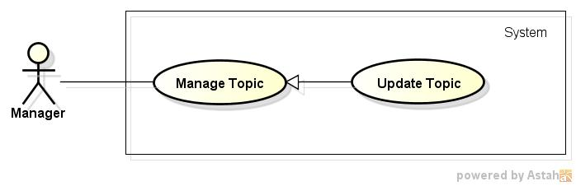

**Figure 52: <Manager>UpdatetopicUse case Diagram**

*3.2.2.5.7.2. Use case Specification*

|  |  |  |  |
| --- | --- | --- | --- |
| **USE CASE –046** | | | |
| **Use Case No.** | 046 | **Use Case Version** | 1.0 |
| **Use Case Name** | Updatetopic | | |
| **Author** | Pham Quoc Thai | | |
| **Date** | 20/05/2015 | **Priority** | High |
| **Actor:**   * Manager.   **Summary:**  In this case, after logging, manager can update of specific topic.  **Goal:**  Update topic successfully.  **Triggers:**  Click on “Cập nhật” link of specific topic on Topic Listpage.  **Preconditions:**  Manager must login into website.  **Post Conditions:**  N/A  **Main Success Scenario:**   |  |  |  | | --- | --- | --- | | Step | Actor Action | System Response | | 1 | Click on “Cập nhật” link of specific topic on Topic Listpage. | Show pop up confirm. | | 2 | Click button "Xác Nhận" | Update topic successfully. | | Click button "Hủy" | Close pop up and return Topic Listpage. |   **Alternative Scenario:**  N/A  **Exceptions:**  N/A  **Relationships:**  N/A  **Business Rules:**  N/A | | | |

3.2.2.5.8. < Manager>Delete topic

*3.2.2.5.8.1. Use case Diagram*

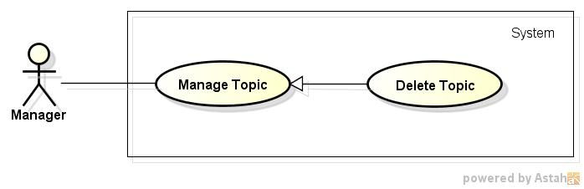

**Figure 53: <Manager>Delete topicUse case Diagram**

*3.2.2.5.8.2. Use case Specification*

|  |  |  |  |
| --- | --- | --- | --- |
| **USE CASE –047** | | | |
| **Use Case No.** | 047 | **Use Case Version** | 1.0 |
| **Use Case Name** | Delete topic | | |
| **Author** | Pham Quoc Thai | | |
| **Date** | 20/05/2015 | **Priority** | High |
| **Actor:**   * Manager.   **Summary:**  In this case, manager can delete of specific topic.  **Goal:**  Topic be deleted successfully.  **Triggers:**  Click on “Xóa” link of specific topic on Topic List page.  **Preconditions:**  Manager must login into website.  **Post Conditions:**  N/A  **Main Success Scenario:**   |  |  |  | | --- | --- | --- | | Step | Actor Action | System Response | | 1 | Click on “Xóa” link of specific topic on Topic List page. | Show pop up confirm. | | 2 | Click button "Xác Nhận" | Topic has been deleted. | | Click button "Hủy" | Close pop up and return Topic List page. |   **Alternative Scenario:**  N/A  **Exceptions:**  N/A  **Relationships:**  N/A  **Business Rules:**  N/A | | | |

3.2.2.5.9. < Manager>Active/ Deactive Topic

*3.2.2.5.9.1. Use case Diagram*

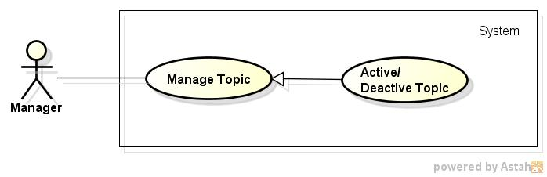

**Figure 54: <Manager>Active/ Deactive Topic Use case Diagram**

*3.2.2.5.9.2. Use case Specification*

|  |  |  |  |
| --- | --- | --- | --- |
| **USE CASE –009** | | | |
| **Use Case No.** | 048 | **Use Case Version** | 1.0 |
| **Use Case Name** | Active/ Deactive Topic | | |
| **Author** | Pham Quoc Thai | | |
| **Date** | 20/05/2015 | **Priority** | High |
| **Actor:**   * Manager.   **Summary:**  In this case, manager can active or deactivetopic.  **Goal:**  Topic be actived or deactived successfully.  **Triggers:**  Click on "Kích hoạt/ Không kích hoạt" link on Topic Listpage.  **Preconditions:**  Manager must login into website.  **Post Conditions:**  N/A  **Main Success Scenario:**   |  |  |  | | --- | --- | --- | | Step | Actor Action | System Response | | 1 | Click on "Kích hoạt/ Không kích hoạt" link on Topic Listpage. | Topic be actived or deactived successfully. |   **Alternative Scenario:**  N/A  **Exceptions:**  N/A  **Relationships:**  N/A  **Business Rules:**  N/A | | | |

3.2.2.5.10. < Manager>View statistic report

*3.2.2.5.10.1. Use case Diagram*

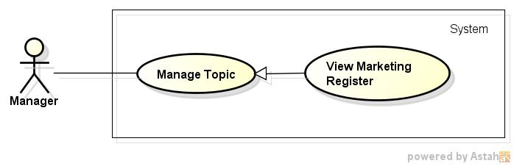

**Figure 55: <Manager>View statistic report Use case Diagram**

*3.2.2.5.10.2. Use case Specification*

|  |  |  |  |
| --- | --- | --- | --- |
| **USE CASE –049** | | | |
| **Use Case No.** | 049 | **Use Case Version** | 1.0 |
| **Use Case Name** | View statistic report | | |
| **Author** | Pham Quoc Thai | | |
| **Date** | 20/05/2015 | **Priority** | High |
| **Actor:**   * Manager.   **Summary:**  In this case, manager can view Statistic report.  **Goal:**  Statistic report display successfully.  **Triggers:**  Click “Statistic Report” tab on Manager home page.  **Preconditions:**  Manager must login into website.  **Post Conditions:**  N/A  **Main Success Scenario:**   |  |  |  | | --- | --- | --- | | Step | Actor Action | System Response | | 1 | Click “Statistic Report” tab on Manager home page. | Statistic report display successfully. |   **Alternative Scenario:**  N/A  **Exceptions:**  N/A  **Relationships:**  N/A  **Business Rules:**  N/A | | | |

3.2.2.5.11. < Manager>Up Marketing Package

*3.2.2.5.11.1. Use case Diagram*

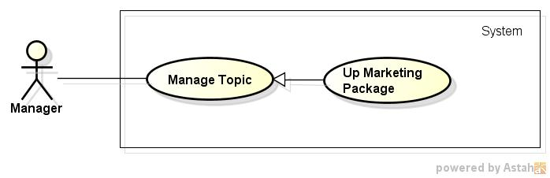

**Figure 56: <Manager>Up Marketing Package Use case Diagram**

*3.2.2.5.11.2. Use case Specification*

|  |  |  |  |
| --- | --- | --- | --- |
| **USE CASE –050** | | | |
| **Use Case No.** | 050 | **Use Case Version** | 1.0 |
| **Use Case Name** | Up Marketing Package | | |
| **Author** | Pham Quoc Thai | | |
| **Date** | 20/05/2015 | **Priority** | High |
| **Actor:**   * Manager.   **Summary:**  In this case, manager up Marketing Package.  **Goal:**  Marketing Package be upped successfully.  **Triggers:**  Click button “Đăng gói quảng cáo ” on Marketing Package Manager page.  **Preconditions:**  Manager must login into website.  **Post Conditions:**  N/A  **Main Success Scenario:**   |  |  |  | | --- | --- | --- | | Step | Actor Action | System Response | | 1 | Click button “Đăng gói quảng cáo ” on Marketing Package Manager page. | Marketing Package be upped successfully. |   **Alternative Scenario:**  N/A  **Exceptions:**  N/A  **Relationships:**  N/A  **Business Rules:**  N/A | | | |

3.2.2.5.12. < Manager>Delete Marketing Package

*3.2.2.5.12.1. Use case Diagram*

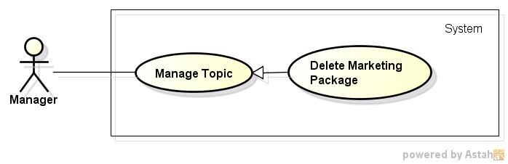

**Figure 57: <Manager>Delete Marketing Package Use case Diagram**

*3.2.2.5.12.2. Use case Specification*

|  |  |  |  |
| --- | --- | --- | --- |
| **USE CASE –051** | | | |
| **Use Case No.** | 0051 | **Use Case Version** | 1.0 |
| **Use Case Name** | Delete Marketing Package | | |
| **Author** | Pham Quoc Thai | | |
| **Date** | 20/05/2015 | **Priority** | High |
| **Actor:**   * Manager.   **Summary:**  In this case, manager can delete of specific Marketing Package.  **Goal:**  Marketing Package be deleted successfully.  **Triggers:**  Click on “Xóa” link of specific topic on Marketing Package Manager page.  **Preconditions:**  Manager must login into website.  **Post Conditions:**  N/A  **Main Success Scenario:**   |  |  |  | | --- | --- | --- | | Step | Actor Action | System Response | | 1 | Click on “Xóa” link of specific topic on Marketing Package Manager page. | Show pop up confirm. | | 2 | Click button "Xác Nhận" | Marketing Package be deleted successfully. | | Click button "Hủy" | Close pop up and return Marketing Package Manager page. |   **Alternative Scenario:**  N/A  **Exceptions:**  N/A  **Relationships:**  N/A  **Business Rules:**  N/A | | | |

3.2.2.5.13. < Manager>View Marketing Register

*3.2.2.5.13.1. Use case Diagram*

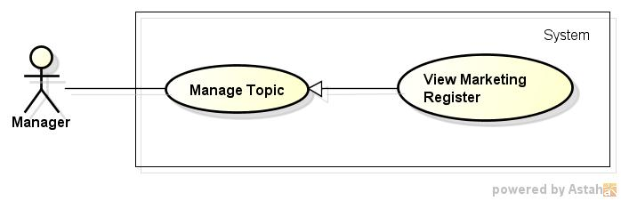

**Figure 58: <Manager>View Marketing Register Use case Diagram**

*3.2.2.5.13.2. Use case Specification*

|  |  |  |  |
| --- | --- | --- | --- |
| **USE CASE –052** | | | |
| **Use Case No.** | 052 | **Use Case Version** | 1.0 |
| **Use Case Name** | View Marketing Register | | |
| **Author** | Pham Quoc Thai | | |
| **Date** | 20/05/2015 | **Priority** | High |
| **Actor:**   * Manager.   **Summary:**  In this case, manager can view marketing register.  **Goal:**  All marketing registers be displayedsuccessfully.  **Triggers:**  Click on tab "Danh sách đăng kí quảng cáo" on Marketing Package Manager page.  **Preconditions:**  Manager must login into website.  **Post Conditions:**  N/A  **Main Success Scenario:**   |  |  |  | | --- | --- | --- | | Step | Actor Action | System Response | | 1 | Click on tab "Danh sách đăng kí quảng cáo" on Marketing Package Manager page. | All marketing registers be displayedsuccessfully. |   **Alternative Scenario:**  N/A  **Exceptions:**  N/A  **Relationships:**  N/A  **Business Rules:**  N/A | | | |

3.2.2.5.14. < Manager>Delete Marketing Register

*3.2.2.5.14.1. Use case Diagram*

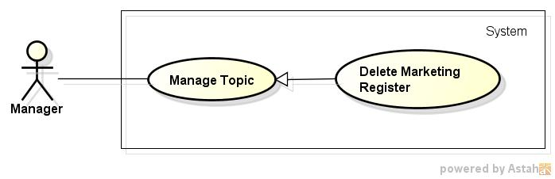

**Figure 59: <Manager>Delete Marketing Register Use case Diagram**

*3.2.2.5.14.2. Use case Specification*

|  |  |  |  |
| --- | --- | --- | --- |
| **USE CASE –053** | | | |
| **Use Case No.** | 0053 | **Use Case Version** | 1.0 |
| **Use Case Name** | Delete Marketing Register | | |
| **Author** | Pham Quoc Thai | | |
| **Date** | 20/05/2015 | **Priority** | High |
| **Actor:**   * Manager.   **Summary:**  In this case, manager can delete of specific marketing register.  **Goal:**  Marketing register be deleted successfully.  **Triggers:**  Click on “Xóa” link of specific topic on Marketing Register List page.  **Preconditions:**  Manager must login into website.  **Post Conditions:**  N/A  **Main Success Scenario:**   |  |  |  | | --- | --- | --- | | Step | Actor Action | System Response | | 1 | Click on “Xóa” link of specific topic on Marketing Register List page. | Show pop up confirm. | | 2 | Click button "Xác Nhận" | Marketing register be deleted successfully. | | Click button "Hủy" | Close pop up and return Marketing Register List page. |   **Alternative Scenario:**  N/A  **Exceptions:**  N/A  **Relationships:**  N/A  **Business Rules:**  N/A | | | |

### 3.2.3. Non-Functional Requirements

#### 3.2.3.1. Reliability

* All the transactions are managed by manager.
* System can perform roll back transaction when errors occurring.

#### 3.2.3.1. Availability

* The system can only run with network connection.
* All the functions can be used every time exclude maintenance time.

#### 3.2.3.1. Security

* Allow user to update account information and change their account password.
* Registry or changing email must require verification.
* The system automatically asks user to change their password every three months.
* All passwords are encrypted.
* Each role of user has a specific permission to interact with system.
* System always checks authorization and authentication before doing anything.

#### 3.2.3.1. Maintainability

* The system is easy to updated or modified, required maintenance time at most 8 hours.
* Data will be backed up once every two weeks.

#### 3.2.3.1. Portability

* The system could be moved to another platform like Android or IOS with 50% module of modules that need changing, with 6 people per 2 months and a half.

#### 3.2.3.1. Performance

## 3.3. Entity Relationship Diagram or Data Structure

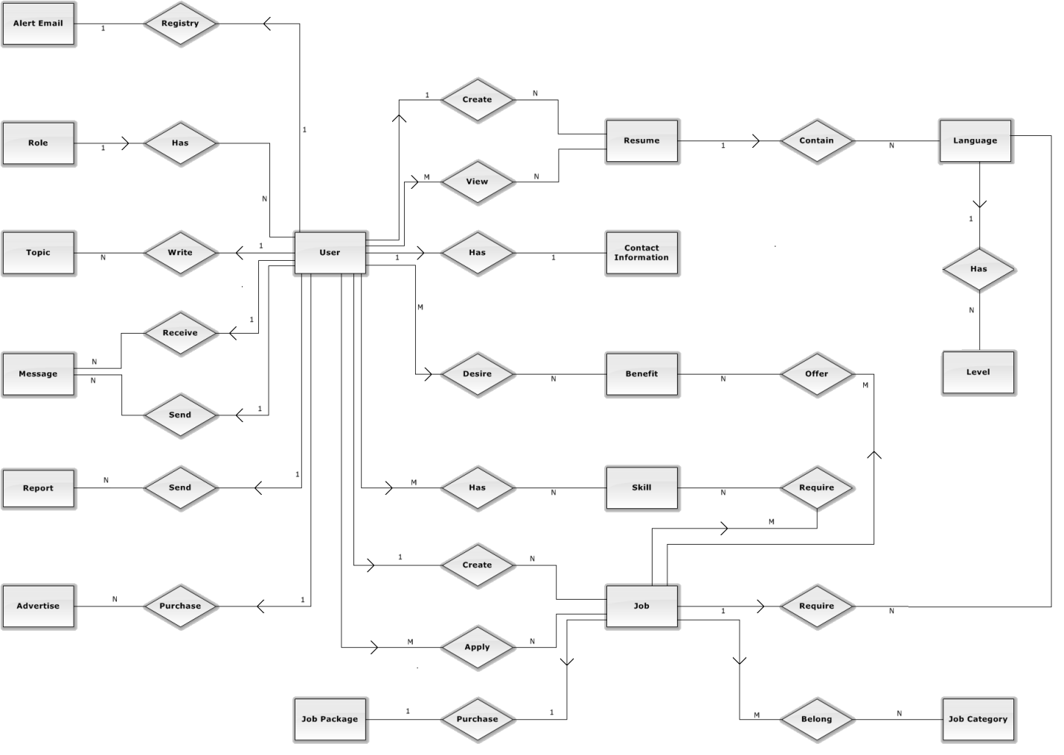

**Figure 50: Entity Relationship Diagram**

## 3.4. Entity Detail

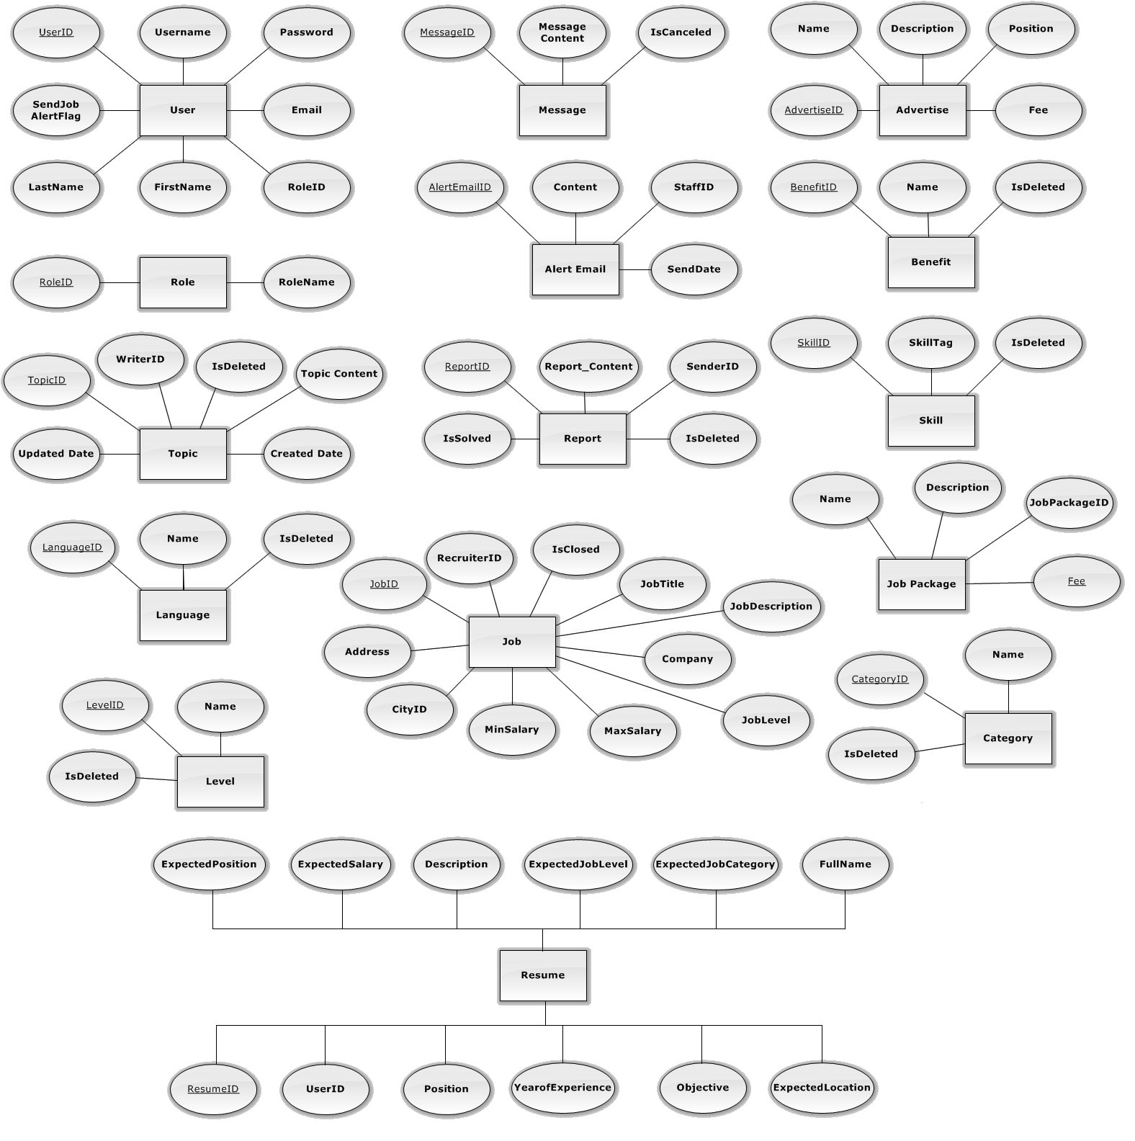

**Figure 51:**  Entity Attributes